CONSTRUCTION SECTOR TRANSPARENCY INITIATIVE
ETHIOPIA (CoST – ETHIOPIA)

ASSURANCE LEVEL REPORT ON REACTIVE DISCLOSURE OF PROJECT PROCUREMENT AND CONTRACT INFORMATION:-
DEBRE TABOR UNIVERSITY: CYT AND DHB PROJECT

By: Endale Bewketu (Assurance Professional)

November, 2018
ADDIS ABABA, ETHIOPIA
Contents
ABBREVIATIONS/ACRONYMS 7
EXECUTIVE SUMMARY 1
1. INTRODUCTION 4
1.1 Background 4
Table 1 List of Documents obtained or provided by MoE and DTU. 6
Table 2 List of missing documents which were not issued. 7
2. Reactive Disclosure of Project Information 8
2.1 Project Overview 8
2.2 Scope of the Project 8
2.3 Socio-Economic Benefits (Purpose) of the Project 9
2.4 Undesired Impacts of the Project 9
2.5 Source of Funding and Project Cost 10
2.6 Project Duration 10
3. Reactive Disclosure of Procurement and Contract Information-Contract-1 11
3.1 Reactive Disclosure of Procurement Information:- 11
3.1.1 Overview of the Procurement Process 11
4. Reactive Disclosure of Procurement and Contract Information Contract-2 11
4.1 Reactive Disclosure of Procurement Information: 11
4.1.1 Overview of the Procurement Process 11
Table 3. Technical and Financial Evaluation Process 13
4.1.2 Verification of the Reactively Disclosed Procurement Information 13
4.1.3 Analysis of the disclosed Procurement Information: 14
4.2 Reactive Disclosure of Contract Information: 16
4.2.1 Overview of the Contract Information 16
4.2.2 Verification of Disclosed Contract Information 17
4.2.3 Analysis of Disclosed Contract Information: 18
5. Reactive Disclosure of Procurement and Contract Information Contract -3 (Works) 19
5.1 Reactive Disclosure of Procurement Information: 19
5.1.1 Overview of the Procurement Process 19
5.1.2 Verification of the Disclosed Procurement Information 20
5.1.3 Analysis of the Reactively Disclosed Information 20
5.2 Reactive Disclosure of Contract Information: 22
5.2.1 Overview of the Contract Process 22
5.2.2 Verification of the Disclosed Contract Information: 22
5.2.3 Analysis of the Disclosed Contract Information 23
6. Findings and Causes of Concerns 24
6.1 Findings 24
6.1.1 Consultancy Service for Contract Administration Construction Supervision Works 24
6.2 Causes of Concerned 25
6.2.1 Time Concerns 25
6.2.2 Cost Concerns 25
6.2.3 Quality Concerns 26
7. Conclusion and Recommendations 26
7.1 Conclusion 26
7.2 Issues Recommended for Further Review 28
Figure1-Library, Vision and Mission of DTU 29
Figure 2-Dormitories (CYT+DHB Buildings) & Road Section (Infrastructure) 30
Figure 2- Main Administrative Buildings and Road Sections 31
Annex 2. Standard Disclosure Template 42
GLOSSARY: ALPHABETICAL LIST OF TERMS 49

LIST OF TABLES
Table 1: List of Documents Obtained or Provided by MoE and DTU
Table 2: List of Missing Documents Required for Reactive Disclosure Information
Table 3: Technical and Financial Evaluation Process for Contact 2
LIST OF FIGURES
Figure 1: Library, Vision and Mission of DTU
Figure 2: Student Dormitories (CYT+DHB Buildings) & Road Section (Infrastructure)
Figure 1: Main Administrative Buildings and Road Sections
Figure 4: Laboratory Buildings
ANNEXES
Annex 1: Standard Disclosure Format for Contract and Project Information Disclosure
GLOSSARY

ABBREVIATIONS/ACRONYMS
A/E  ANRS  ANRSHDPO  AP  CoST  CYT  DHB  DTU  E.C.  FDRE  ETB  IDS  MoE  MoWUD  NMSG-EC  PPAA  SDT/F  TR  UCBP  VAT  VOs | Architectures and Engineers  Amhara National Regional State  Amhara National Regional State Housing Development Project Office  Assurance Professional  Construction Sector Transparency Initiative  Court Yard Type  Department Head Building  Debre-Tabor University  Ethiopian Calendar  Federal Democratic Republic of Ethiopia  Ethiopian Birr  Infrastructure Data Standard  Ministry of Education  Ministry of Works and Urban Development  National Multi-Stakeholder Group Executive Committee  Procurement & Property Administration Agency  Standard Disclosure Template/Format  Terms of Reference  University Capacity Building Program  Value Added Tax  Variation Orders

EXECUTIVE SUMMARY
Construction Sector Transparency Initiative (CoST) aims to enhance the Transparency and Accountability of public-funded construction projects. The CoST’s expectation is to improve transparency & accountability which can lead to better management facilities & controlled use of public projects and also desirous to disclose accurate and complete disclosed information on selected sample projects during the capacity building training. To ensure that the information released is both accurate and available in a form that can easily be understood by stake holders, it would need to be verified and analyzed by the expert. In order to achieve this crucial task, NMSG-EC has appointed an Assurance Professional (AP) who is responsible to provide the professional expertise on data collection and verification process of reactively disclosed information. AP is also responsible to prepare an intelligible report on accuracy and completeness of the disclosed information by highlighting the main findings and causes of concerns. Thus, AP has taken responsibility to carry out the above mentioned task as stipulated in the contract agreement.
Description of the project and contracts included in the report are described as follows:
Date of Disclosure and Assurance: April 25, 2018 G.C.
Name of Assurance Professional: Endale Bewketu
Project Name: Debre University CYT and DHB
Project Location: Project is found in Amhara National Regional State, on the Eastern Part of Historical Town ``Debre-Tabor`` at about 4 (four) kms away from the center of the town and it is located at 11° 51′ North of Latitude & 38° 01′ East of Longitude.
Project Owner: Debre Tabor University
For the execution of Infrastructure Project, the following contracts have been involved:
Contract 1: Consultancy Service for Design Adaptation and Construction Supervision (Topology Adaptation).
Consultant: MH Engineering PLC Consulting E/A:
Date of Contract Agreement: on May 15, 2009 G.C. between MoE & MH Engineering PLC Consulting E/A.
Contract 2: Consultancy Service for Planning, Design Adaptation and Supervision Works (Contract Administration). Consultant- Ultimate Plan PLC Consulting A/E (Contract agreement made on 25th September, 2009 G.C. between MoE & Ultimate Plan PLC Consulting A/E).
Contract 3: Works (CYT & DHB Buildings).
Contractors: Fourteen (14) different contractors from ARHDPO have been involved.
The Contract Agreements were made between FDRE- MoE, Ten (10) New Universities Construction Project Office and fourteen (14) different contractors from Amhara Regional State Housing Development Program Office have been involved in the construction of Administrative & Student Dormitories. Contract Agreement dates were different.
The service contract for Design Adaptation and Construction Supervision (Contract 1) of Debre-Tabor University (which is among Ten New Universities) was issued to MH Consulting Engineers PLC based on the participation of previous 13 Universities Preliminary and Detail Design. For consultancy service of Contract Administration and Construction Supervision Works (Contract 2), only two (2) consultants were evaluated for their technical and financial proposals. AP has identified that different Supplementary Contracts such as Outdoor Sport Facilities and phases I and II Infrastructures Works (Roads, Sanitary, and Electrical Works, for the contract prices of 20, 709, 372.35 million Birr & 14,250,582.21 million Birr including VAT respectively) have been given repeatedly to the same contractors in addition to the main contract (which was 100,880,626.32 million Birr). During the overall assessment of documents issued by MoE, Ten New Construction Project Office, AP has identified the causes of construction time delays, due to the unavailability of consultant’s construction supervisors on project site & problems in providing job orders to the contractors.
Assurance Professional (AP) has faced some challenges during the first trip of data collection time. In the late time, Later on Especially of obtaining necessary project information and required data (such as Feasibility Studies & Engineering Cost Estimate Documents, Bid Invitation & Tender Evaluation Documents for consultancy service contracts 1 & 2, Contract Agreement Document for CTY & DHB Contractors, Scope or Contract Change Information, ). It is recalled that CoST-Ethiopia has written a letter on 23/11/2010 E.C. to Debre Tabor University in order to cooperate in providing the required documents depending on the basis of AP’s request. Accordingly, DTU has responded on 12/09/2010 E.C. that some main documents were not available in the university; however, DTU has given information where the required documents could be available and found.
Assurance Professional has identified the occurrence of different problems that has been influenced the construction activities. The associated problems that have been addressed in the available documents were poor coordination between the consultant (contract-2) and the contractor, design problems in road works, problems of consultant in timely provision of necessary information to the contractors, problems associated with consultant's construction supervisors not available at the construction sites at the right time at the right place, delay of release of finance on time and as necessitated to execute the construction activities properly, were main problems identified during the overall assessment of the available documents.

INTRODUCTION

Background
Cost Ethiopia is principally about increasing transparency through the release of project information in to the public domain. But it is recognized that the disclosure of this information may not be sufficient on its own to achieve greater accountability. This is because some of the information is likely to be complex and not easily intelligible to the general public. To ensure that the information released is both accurate and available in a form that can easily be understood by stakeholders, it would need to be verified and analyzed by the experts.
- The Overall Content of the Report:
The CoST-Ethiopia is aimed to know the transparency and accountability issues on public-financed Projects. In order to achieve this aim, the National Multi-Stakeholder Group-Executive Committee (NMSG-EC) has appointed an Assurance Professional (AP), who is responsible to carry out the Reactive Disclosure Information on publicly-financed construction projects. In order to perform this task, two sample projects had been selected from DTU (the Infrastructure and CYT and DHB Projects). Under this part, DTU’s CYT & DHB Project will be discussed.
- AP is responsible to carry out the required task according to the terms of reference (ToR) stipulated in the contract agreement by collecting adequate and relevant documents and information from PE’s and where necessary from consultants and contractors in collaboration with the assigned PE’s staffs. To do this AP has traveled to the project site on Tuesday March 17, 2018 G.C. During the first project site trip, AP has made short and brief discussions with the contemporary President of DTU and assigned staffs about the overall objectives of CoST-Ethiopia and responsibilities of AP. President of DTU has shown an enthusiastic willingness to cooperate in providing or issuing all necessary documents and information required, and he has directed the letter written by CoST-Ethiopia, the letter asking DTU’s cooperation in providing all essential documents and information necessary for Public Disclosure Process to the assigned AP. Based on the available documents and information obtained, AP will verify and analyze the project information for its accuracy and completeness, and produce reports that are clearly intelligible to the non-specialists by highlighting main causes of concerns. Basically, conducting accurate and complete disclosed information on selected sample projects will rely on the availability of adequate and relevant documents from respective Procuring Entities and if possible, from consultants and contractors.
- Objectives of Reactive Disclosure and Assurance Services:
- To verify the accuracy and completeness of Infrastructure Data standard (IDS) as outlined in the reactive disclosure information on the sample CoST projects,
- To analyze disclosed and verified data in order to make informed judgments about the cost, time and scope aspects of the CoST Project, and
- To produce reports that are clearly intelligible to the non-specialist, outlining the findings in regard with the cost and quality of the infrastructure and highlighting any cause for concern that analyzed information revealed on CoST Projects.
- Activities of Reactive Disclosure and Assurance Services:
- Collects project information from the PEs (in close collaboration with staffs from PEs) and, where necessary also collects information from consultants and contractors on selected projects in order to insure the publication of IDS as outlined in the Reactive Disclosure Standards of CoST-Ethiopia,
- Verifies the accuracy and completeness of the information collected,
- Makes site visit to have visual impression of the project and continues to make additional verifications as required,
- Produces reports that are clearly intelligible to the non-specialist, highlighting the main findings and causes of concern analyzed information reveals,
- Makes presentation to NMSG-EC, multi-stakeholder forums, get feedbacks and refine the reports accordingly.
- Challenges that AP has faced during data collection Process: According to the work schedule, the first field trip to the project site was on Tuesday March 17, 2018. On the occasion, the short and brief discussions were held with DTU President and assigned staffs about the overall objective of the AP’s assignment. , AP has been faced the following challenges during the data collection and verification process of reactive disclosure information:
- Unable to have a contact and communication with DTU’s Construction Project Coordinator,
- Problems in obtaining adequate and relevant documents and information,
- Existence of limited cooperation in providing available documents and relevant information.

Table 1 List of Documents obtained or provided by MoE and DTU.
Serial No. | Issued Documents | Procuring Entities |  | Remark
 |  | DTU | MoE
1 | Contract Agreement document for Infrastructure Works (for Contract-3)
2 | Payment Certificates (1-14) of Infrastructure Works
3 | Contract Agreement Documents for 14 contractors who were involved in the construction of CTY & DHB |  |  | Out of 14 contractors who were involved, only for 2 contractors of contract agreement documents were issued by DTU.
5 | Supplementary work contract documents & outdoor sport facilities documents
6 | Variation Orders No. 2 & No.3 for contractors of Infrastructure Works
7 | Contract Agreement document for Consultancy service of Contract Administration & Construction Supervision work |  |  | This document exists in the DTU office, but we were unable to provide the document because it’s huge size.
8 | Technical & Financial Evaluation Process Document (unofficial document) for the service of Contract Administration & Construction Supervision Works
9 | Selection information (unofficial Document) for consultancy Service of Design Adaptation & Construction supervision –Contract-1
10 | Progress report
11 | Audit Report Document

Table 2 List of missing documents which were not issued.
Ser No. | Required Documents | DTU’s response about the Documents | MoE’s responses about Documents | Remarks
1 | Feasibility Study Report Document | This document may be available in MoE, but not available in our office. | Feasibility study was not carried out for the implementation of 10 new universities including DTU. | AP has requested Ultimate Plan consulting A/E for the relevant documents in relation to DTU, unfortunately the firm could not cooperate
2 | Bid Invitation & Tender Evaluation Documents for consultancy services (contracts 1 & contract 2) | Bid Invitation & Tender Evaluation processes for consultancy services 1 & 2 were performed and evaluated by MoE, thus the documents can be obtained from MoE. | Official Bid Invitation & Tender Evaluation documents are available in our deadly storage room. There were no assigned documentation workers who are responsible and provide the required documents.
3 | ‘’Performance Directive Document’’ that was used the selection process of Infrastructure Contractor & CYT & DHB contractors. | The selection processes of contractors were based on their previous performances obtained during their participation in the housing development program, and the contract was given to the contractors on fixed price basis, but the so called Performance Directive document used to select contractors is not found in our office. | The Performance Directive Document was prepared by the Addis Ababa Housing Development Agency and distributed to the regional Housing Development Offices, thus the document may be available Offices of Agencies.
4 | Anticipated scope changes and contract prices changes | There were no any anticipated scope and contract price changes during CYT & DHB construction activities. | No information concerning project scope and contract price changes during the DTU project constructions
5 | Documents related to Engineering Cost Estimates | Engineering Cost Estimate was prepared by MH consulting A/E, after it has got an acceptance from MoE, and the document was distributed to the contractors on fixed price basis, & the document can be obtained from MoE & MH Consulting Plc. | Engineering cost estimate was prepared by responsibility of Addis Ababa Urban Development Office, and may be available there.

Reactive Disclosure of Project Information

Project Overview
The government of the Federal Democratic Republic of Ethiopia (FDRE), in its five years Development and Economic Growth Plan (Sustainable Development and Poverty Reduction Program, 2002-2007), has considered the Education Sector Program as a Cornerstone of the Capacity Building, Poverty Reduction and Sustainable Development Strategy. In addition to ensuring access to elementary education for all citizens, the education sector program aims to expand secondary and tertiary education throughout the country. Special Emphasis is placed on expansion of educational services in underprivileged regions and remote areas to achieve the important objectives of political and administrative decentralization, and balanced and equitable growth of the economy. It is primarily in line with this strategy that the construction of Ten (10) New Universities under UCBP has been envisaged and being implemented.
Debre-Tabor University is among the construction of Ten (10) New Universities to be implemented under five years Development and Economic Growth Plan. DTU was established in 2008 G.C., and its foundation had laid on the eastern part of the Historic Town Debre-Tabor at about 4 (four) Kms away from its center on 126 hectares of land. This area was previously owned by 268 farmers to whom nearly 10.5 million Birr was paid for compensation and rehabilitation. Among the 268 farmers, only 10 ceased farming and engaged in other occupations to earn their living. It was attempted to construct a total of 134 buildings out of which in the first round 35 buildings, in the second round 32 and in the third round 32 were successfully planted while the final 35 are on construction in 2007 fiscal year. Debre-Tabor University is found on the eastern part of historical Town ``Debre-Tabor`` at about 4 (four) kms away from the center of the town and it is located at 11° 51′ North of Latitude & 38° 01′ East of Longitude.

Scope of the Project
Debre Tabor University was among Ten (10) New Universities which was established in 2008. It was attempted to construct a total of 134 buildings out of which infrastructure project includes all works of Road, Sanitary and Electrical Installations all around the surrounding campus. The Overall Facility of Infrastructure works were executed only by one contractor and project is 100% completed and under service three years ahead of.
The university commenced its mission in 2011(2004 E.C.) and according to the statistics indicated the number of students enrolled in regular programs, in 2004 (2011/2012) Academic Year were about 311 Male & 317 Female Students, total of 628 students. However, this number has grown rapidly to 5015 Male & 2792 Female, total of 7807 enrolled students in Academic Year of 2007 E.C. (2014/2015 G.C.)

Socio-Economic Benefits (Purpose) of the Project
Debre Tabor University is dedicated to the supply of highly qualified and innovative human resource by providing societal needs-tailored quality education. Students will form the backbone of a qualified and adaptable human resource base that will drive Ethiopia’s Economic Development Forward. DTU comprises different facilities in it and among these facilities the infrastructure works were major facilities which provide road accesses, sanitary facilities, and electrical uses for the university communities of beneficiaries.

Undesired Impacts of the Project
Environmental Impact Issues:
Environmental Impact Assessment (EIA) is a key aspect of many large scale planning applications. It is a technique which is meant to help us understand the potential environmental impacts of major development proposals. In a nut shell, EIA is just an information gathering exercise carried out by the developer and other bodies which enables a Local Planning Authority to understand the environmental affects of a development before deciding whether or not it should go ahead. The really important thing about environmental assessments is the emphasis on using the best available sources of objective information and in carrying out a systematic and holistic process which should be bias free and allow the local authority and the whole community to properly understand the impact of the proposed development. Environmental assessment should lead to better standards of development and in some cases development not happening at all.
Construction of DTU which includes infrastructure facilities has required about 126 hectares (1.26 km²) of land, which has been previously owned by 268 farmers, and nearly ETB=10,535,105.70 was paid for compensation and rehabilitation of those displaced Farmers. Among the 268 farmers, only 10 ceased farming and engaged in other occupations to earn their own living standards. AP considers as undesired impact here is that the statement in the document does not explain or address the final destinies of about 258 displaced farmers.

Source of Funding and Project Cost
The project is fully funded by The Government of Federal Democratic Republic of Ethiopia. From an unofficial source (document without official stamp) the initial estimated budget for the DTU construction project was ETB= 600,000,000.00 (Six Hundred Million). No clear documents or evidences which ascertain or verify this information. This was information obtained from Ato Tamene, 11 New Universities Construction Project Office Engineer, MoE.

Project Duration
The construction of DTU Infrastructure was divided in Two Phases based on their subsequent priorities. As stated in the contract agreement, the total construction duration for each phase was 365 Calendar days or 730 calendar days (Two Years) for the two phases. The contract agreement for the execution of Infrastructure was made on the date of 10th June, 2011 G.C (02 June, 2003 E.C.) that is from June 2003 E.C to the End of May 2004 E.C. Even though, at this time project is completed and providing its full service. But no clear evidence or documents were available to disclose whether the project is completed within the specified period of time as contract agreement or not. For the purpose of disclosure process, finding further information will continue and added in the final report.

Reactive Disclosure of Procurement and Contract Information-Contract-1

Reactive Disclosure of Procurement Information:-

Overview of the Procurement Process
Note: Assurance Professional (AP) will not further discuss concerning the Reactive Disclosure of Procurement and Contract Information concerning Consultancy Service -1 (Contract-1). The following information is only to highlight and introduce the NMSG-EC that who was the consultant involved in the Design Adaptation Providing Design Guide line or consultation, and, Topology Adaptation for Debre –Tabor University.
According to the information obtained from MoE, Design Adaptation up on slight modifications from the design experiences of previous thirteen (13) Universities, Provision of Design Guide Lines to the Newly Constructed Ten (10) Universities and Topology Adaptation were carried out by MH Consulting Architectures and Engineers Plc. However, there were no evidences disclosing about procurement and contract processes.
According to the information obtained from Eleven (11) University Construction Project Office, MH consultant was selected from his previous experience basis gained during the involvement of Design and Supervision of 13 Universities The selection process was based on consent of Higher Officials who were represented from MoE. In general, MH Consultant was selected for the Design Adaptation, Providing Design Guide Lines, and Typology Adaptation at a total contract price of ETB= Eleven (11) Million for Ten (10) New Construction of Universities including Debre-Tabor University.

Reactive Disclosure of Procurement and Contract Information Contract-2

Reactive Disclosure of Procurement Information:

Overview of the Procurement Process
The Contract Agreement for the consultancy service for Planning, Design Adaptation and Supervision Works (Contract Administration) was made between MoE and Ultimate Plan Plc Consulting Engineers and Architectures, on the day of September 25, 2009. The Procuring Entity has requested the supplier to carry out the above consultancy service and the Procuring Entity shall pay the supplier the contract Price of ETB=5,583,825.00 (Five Million Five Hundred Eighty Three Thousand Eight Hundred Twenty Five, including 15% VAT).
The Period within which the Service shall be commenced is Two (2) Weeks after the signing of the Contract.
- Contract Duration for Design Work was Three (3) Months after the commencement of the design works,
- The Construction Supervision and Contract Administration Consultancy Service have been continued until the project completion.
As stated in the unauthorized document (document without official stamp) issued by MoE, bid invitation process has been carried out by the MoE. But the date of bid invitation, total number of registered bidders, and rejected bidders with the reason were not stated in the available document. In the Technical and Financial Evaluation procedures, only two (2) candidates were evaluated for their final nomination.
On the basis of technical and financial evaluation points, Ultimate Plan Consulting A/E Plc has been selected for Planning, Design Adaptation and Supervision Works (Contract Administration) of both DTU Projects (Infrastructure & CYT & DHB). It was recalled that CoST-Ethiopia has written a letter to 10 new University Construction Project Office, MoE on the day of 09/08/2010 E.C. After accepting the official letter, project office has shown an enthusiastic corporation as much as possible. For this takes, 11 New Universities Construction Project Office Engineer Tamene Yigletu was the responsible one who facilitated providing available documents. He has cooperated providing relevant documents, except bid invitation & Tender Evaluation Documents for both consultancy services contract 1 & 2. After essential discussions, AP has tried to observe documentation store, the store was deadly locked store, i.e. it has been closed for years, no any responsible worker in providing required document, and documents were placed disorderly, thereby difficult to identify the required documents.
Generally the store was highly in a messed condition so that the situation has become very difficult to separate and found the required document as needed. There was no a responsible workers who can identify and provide the desired document. Because of above stated difficult situation, AP was unable to get an official Bid Invitation & Tender Evaluation Documents and has faced producing accurate and complete disclosed information about Bid advertisement and tender evaluation processes.
The figures tabulated in the Table 3 below describes Technical and Financial Evaluation process as was taken from unauthorized (unofficial) document obtained from the MoE. AP is responsible for this information and used this information only to verify that Tender Evaluation processes have been carried out by the MoE.

Table 3. Technical and Financial Evaluation Process
No | Bidders' Name | Final Accepted Contract Amount (exclusive of 15% VAT) | Weighted technical score (80%) | Weighted financial score (20%) | Total Score (100%) | Rank
1 | Ultimate Plan A/E Plc | ETB=5,494,125.00 | 72.5 | 16 | 88.5 | 1
2 | National Consulting A/E Plc | ETB=5,777,866.00 | 70.8 | 14.6 | 85.4 | 2

Verification of the Reactively Disclosed Procurement Information

Completeness of the Disclosed Procurement Information
Verifying the completeness of Disclosed Procurement Information substantially relies on the issued or provided documents or information by the concerned procuring Entities. From the Standard Disclosure Format Requirement, the average completeness of reactive disclosure of procurement information was about 55%.

Accuracy of the Disclosed Procurement Information
Accuracy of the Disclosed Procurement Information mainly relies on the issuance of related documents by each contracting bodies. Very limited documents were issued from MoE. The Accuracy of the Disclosed Procurement Information can be taken from SDT as 50%.

Analysis of the disclosed Procurement Information:

Compliance of the procurement Process with Rules of Advertisement
As observed from unofficial document, Ultimate Plan Consulting Architectures and Engineers Plc was select on the basis of Technical and Financial Evaluation process for the execution of Planning, Design Adaptation and Supervision Works (Contract Administration) of DTU projects. In order to verify whether procurement process (on time bid invitation, appropriate bidding dates, fair registration of competent bidders, reliable selection and rejection processes ) was in compliance with rules of advertisement or not, it shall have been cross-checked from authorized documents , however this was not happen.

Efficiency of the Procurement Process
Official documents revealing about timely bid advertisement, number of registered bidders, rejected bidders, number of selected bidders, date of bid proposal submission, bid opening, appropriateness of bid evaluation process (technical and financial evaluation) were not available, and as a result AP was unable to verify the efficiency of the procurement process.

Fairness of the procurement Rules on Participation
In order to verify fairness of the procurement rules on participation solely relies on the concrete evidences or relevant documents, as a result this was not possible due to missing documents.

Transparency of the Tender Evaluation Process
For the service of Planning, Design Adaptation, Construction Supervision (Contract Administration), three candidates were evaluated for their Technical and Financial Capacities, as discussed in section 5.1.1; the least bidder or supplier (ultimate Plan Consulting firm Plc) was selected among other two candidates. However, this information was obtained from the unauthorized/unofficial document issued by MoE, but it was not cross-checked from the concrete evidences.

Objectivity of the Tender Evaluation and the Award Criteria
The evaluation of tenders is the stage in the procurement process during which a contracting authority identifies which one of the tenders meeting the set requirements is the best one on the basis of the pre-announced award criteria, either the lowest-priced or the most economically advantageous tender. The qualified tenderer whose tender has been determined to be either the lowest-priced or the most economically advantageous, as the case may be, is awarded the contract.
The award criteria are the criteria that constitute the basis on which a contracting authority chooses the best tender and awards a contract. These criteria must be established in advance by the contracting authority and must not be prejudicial to fair competition. In order to confirm the above objectivity of Tender Evaluation and Award Criteria in the implementation of DTU infrastructure works.

Competitiveness of the Award Criteria
Only two consultants were evaluated for the consultancy service of Contract Administration and Construction Supervision. The detail award process was not clearly stated in the available document. As there were no additional supporting documents and clear information, verification and analysis was not satisfactorily carried out by AP in order to compare and contrast the competitiveness of the award criteria between the competitive bidders.

Overview of Contract Milestones: Original scope, Time and Cost
From the latest response or information obtained from DTU’s assigned members, there were no any changes concerning original project scope, time, & cost issues. Moreover, documents revealing the changes of original project scope, time, and cost were not available; AP is responsible for this disclosed information

Reactive Disclosure of Contract Information:

Overview of the Contract Information
The contract agreement was made between MoE and Ultimate Plan Plc on the day of 25th September, 2009 G.C. The procuring Entity has requested the supplier to provide certain consultancy services as defined in the contract. The supplier having represented the Procuring Entity that it has required professional skills, personnel and technical resources, having agreed to provide the services on the terms and conditions set forth in the contract. According to the contract document, the supplier or consultant will provide the overall service on Planning, Design Adaptation and Construction Supervision (Contract Administration).
In the Contact Document, the following statements had been described and agreed between the two parties (MoE and the supplies or consultant):
- The Mutual Rights and Obligations of Procuring Entity and the Supplier shall be as set forth in the contract, in particular:
- The supplier shall carry out the services in accordance with the provisions of contract; and
- The Procuring Entity shall pay the supplier the contract price of ETB= 5,583,825.00 (Five Million Five Hundred Eighty Three Thousand Eight Hundred Twenty Five) including 15% VA) and other sum as may become payable under the provision of contract, at the time and in the manner prescribed by the Contract. This contract price include for Infrastructure, CTY & DHB contract prices.
The Period within which the Service shall be commenced is Two (2) Weeks after the signing of the Contract. Contract Duration for Design Work was Three (3) Months after the commencement of the design works. Planning Design Adaptation, Construction Supervision (Contract Administration) Consultancy Service has been continued until the project completion.

Verification of Disclosed Contract Information

Completeness of the Disclosed Contract Information
Verifying the completeness of Reactively Disclosed Procurement Information substantially relies on the issued or provided documents for cross-checking purposes. Full Contract Document for the service of Planning, Design Adaptation, and Construction Supervision was obtained only from MoE, Ten New Construction Project Office. Even though, the document issued by MoE, was complete and official document, for need of further cross-checking purpose of completeness of Reactively Disclosed Contract Information, the additional documents/evidences shall have been provided by DTU. Thus, the completeness of disclosed contract information will be one sided. Hence AP has put his own judgment that the completeness of reactive disclosure of contract information was 75% on the basis of SDF requirement.

Accuracy of the Disclosed Contract Information
The accuracy of disclosed contract information also depends on the availability of adequate and relevant documents and further attempt will continue to provide additional information. As required in SDT Accuracy of the Disclosed Procurement Information can be taken as 70 %.

Analysis of Disclosed Contract Information:

Issues Related to Contract Price

Documents revealing any deviation or anticipated contract price changes were not issued contemporarily from both of bodies, MoE, and DTU. As a result providing reliable information about changes on contract price compared to the original contract price. Thus, AP was unable to include justified and confirmed information on changes to the original contract price.

Issues Related to Contract Duration
As stated in the contract agreement document: the period the expiration of the contract for the design work is:
- Three (3) months after the commencement of design work or such other time as parties may agree;
- The Construction Supervision and Contract Administration Consultancy Service: up to the completion of the construction work.

Issues Related to Contract Scope
Documents explaining or revealing any contract scope or project program changes were not issued by MoE, DTU, Consultants, or Contractors. Basically the documents issued/provided by MoE DTU assigned staff was very limited and further assessment and justification were influenced. Thus, producing necessary and reliable information concerning any changes of contract scope, compared to original contract scope was a crucial problem in this report.

Reactive Disclosure of Procurement and Contract Information Contract -3 (Works)

Reactive Disclosure of Procurement Information:

Overview of the Procurement Process
A priority concern for the Government of Ethiopia, for the implementation of Ten (10) New Universities was promoting and encouraging the involvement of those contractors participating in the Regional Housing Development Programs. FDRE has given a mandate to Debre Tabor Construction Housing Development Agency to carry out the construction of CYT & DHB buildings of DTU. The construction of Debre Tabor was based on Fixed Price Contract Basis. From the point of view of Fixed Price Contract Basis, AP perceives the requirements for Bid Advertisement and Tender Evaluation Processes will not necessarily considered for the selection procedure of respective contractors.
The execution of DTU Administrative Offices and Student Dormitories (CYT & DHB) were given to the contractors who were selected on the basis of Fixed Price and Best Performances gained from their past Housing Development Construction Practices. As stated in the contract documents, ‘’the selection process of contractors, who were desired to be engaged in the construction of DTU projects (CYT & DHB ) were privileged according to the Directive Set for the Execution of Ten New Universities’’. The point to be stressed here is the question of hallmarking what was the general content of the ‘’Directive Set for the Execution of Ten New Universities’’ and was it in compliance with principles and procedures set in Public Procurement Processes? This shall be checked only when ‘’Performance Directive’’ Document is obtained
Thus, it was not possible to conclude, whether or not the procedure used for the selection process of contractors was in compliance with the rules and principles stipulated in Public Procurement.

Verification of the Disclosed Procurement Information

Completeness of the Disclosed Procurement Information
The procedure for the selection of contractors in CYT & DHB construction activities was based on the previous participation in the construction of Amhara Regional Housing Development and best performances of contractors during their achievements. Completeness of reactive disclosure of procurement information from SDT count was about 75%.

Accuracy of the Disclosed Procurement Information
The selection procedure was as stated above in section 5.1.2.1, and accuracy of reactive disclosure of procurement information from SDT count was taken as 70%.

Analysis of the Reactively Disclosed Information

Compliance of Procurement Process with the Rules of Advertisement
In order to cross-check about the conformity of procurement process with rules of advertisement, any documented selection process or procedures supported with concrete evidences shall have been obtained, however, this was not happened. AP understands that the selection process has its own procedure and rules that may follow stipulated steps or rules that are contained in the PPAA document.

Efficiency of the Procurement Process (Timeliness)
The efficiency of the procurement process depends on the selection procedure/process that was used for selection of contractors with best performances in the Housing Development Programs.

Fairness of the Procurement Rules on Participation
Fairness of the procurement rules on participation depends on the selection format of Performance Directive document used for selection process of contractors. To provide complete and accurate information, whether or not the selection process was in compliance with the procurement rules of the standard document, it requires further analysis based on the detail contents of the document.

Transparency of the Tender Evaluation Process
As was discussed in detail in the above sections, all contractors who were involved in the construction of CYT and DHB were selected based on their previous construction performance levels and the contract agreements were held on fixed price basis. AP understands that the transparency of tender evaluation process may not be necessarily carried out during the selection process. Since, the selection criterion has been set or has been negotiated among the respective parties for the selection of required contractors.

Objectivity of the Tender Evaluation and award Criteria
The evaluation of tenders is the stage in the procurement process during which a contracting authority identifies which one of the tenders meeting the set requirements is the best one on the basis of the pre-announced award criteria, either the lowest-priced or the most economically advantageous tender. The qualified tenderer whose tender has been determined to be either the lowest-priced or the most economically advantageous, as the case may be, is awarded the contract. The award criteria are the criteria that constitute the basis on which a contracting authority chooses the best tender and awards a contract. These criteria must be established in advance by the contracting authority and must not be prejudicial to fair competition.

Competitiveness of the Award Price
The Contract Award Price was based on the fixed price basis, thus AP considers under this type of selection process, award price competitiveness may not be carried out.

Overview of Contract Milestones: Original scope, Time and Cost
There were no observed or registered changes on original contract scope. Concerning time and cost issues, moreover, in the latest information, DTU assigned staff has corroborated that there were no changes concerning original scope, time, and cost issues. Thus, AP could not verify concerning these issues, as a result complete and accurate information was not addressed to NMSG-EC.

Reactive Disclosure of Contract Information:

Overview of the Contract Process
The selection process for the construction of DTU Projects (Court Yard Type and Decentralized Head Office/Administrative Buildings), was based on mutual consensus made between MoE and ANRSHDPO. According to the documents obtained from both PEs, ANRSHDPO shall deliver those contractors who have participated and acquired best performances in the construction of housing development programs. For the execution of DTU Projects about Fourteen (14) Contractors with Grade III-VI have been engaged. Among the 14 contractors, majority were made a contract agreement on the 3rd day of March, 2011 G.C. The sum of the total contract price of those 14 contractors was, ETB=158,679,465.13 (One Hundred Fifty Eighty Million Six Hundred Seventy Nine Thousand Four Hundred sixty five 13/100) on the fixed price basis.
The contract process of works had followed the direction set out in the inception document involving Performance Based Short Listing of Contractors by Regional Housing Development Offices. The Joint assessment of the offices’ recommendation was carried out by a committee comprising representatives of MoE and Regional Housing Development Project Offices and final approval by the Higher Management Body of the Ministry of Education.

Verification of the Disclosed Contract Information:

Completeness of the disclosed Contract Information
The information about the participation of fourteen (14) contractors in the construction of CYT & DHB buildings was obtained only from MoE. No documents were available from DTU’s Offices for cross-checking purposes. However, AP shall take responsibility that Reactive Disclosure of Contract Information was complete, since full document was obtained from MoE. The degree of completeness of reactive disclosure of contract information from SDT count was taken as 80%.

Accuracy of the Disclosed Contract Information
In order to verify the accuracy of Reactive Disclosure of Contract Information, the information which carries the similar contents shall have been obtained from both parties. But the information was one sided, thus AP may consider the accuracy of disclosed contract information may be taken as 70%.

Analysis of the Disclosed Contract Information

Issues Related to Contract Price
There was no any information or document revealing about contract prices changes. In addition to this DTU staff has confirmed that there were no changes concerning contract prices.

Issues Related to Contract Duration
There was no any information or document revealing about contract duration changes. Besides, DTU staff has confirmed that there were no changes concerning contract duration.

Issues Related to Contract Scope
The contract scope changes were not stated in any of documents obtained, in addition to this information the client has responded that there were no any changes related to contract scope.

Findings and Causes of Concerns

Findings

Consultancy Service for Contract Administration Construction Supervision Works
According to the documents issued/obtained from MoE, there were number of information addressing problems associated with the services of Ultimate Plan Plc. The problems stated in the documents were as described below:
- In most cases, consultant side construction supervisors, were not available on the project site on time and unable to provide work directions to the contractor side workers;
- There were problems in providing necessary and completed design works to the contractors to begin their construction activities as early as possible in accordance with the time scheduled;
- Problems in submitting copies of contractors’ contract agreement that was made with MoE and consultant’s coordination problems with contractor side workers has created serious problems on day to day construction activities;
- There was Road Design Problems that leads to the extra cost increment and time delay;
- Delay of release of finance on time and as necessitated; were the major ones,
It is remembered that CoST-Ethiopia had written a letter on 23/11/2010 E.C. to the DTU, for the additional documents and DTU has responded on the date of 09/12/2010 E.C. AP has careful assessed those documents and identified that DTU has given thanks letter for good achievement/ performance to Ultimate Plan A/E Plc despite the fact that all the above problems (a- e) were happened. According to AP’s opinion, provision of such confirmation letter shows that the client was reluctant to the problems that have been happened. For all of the findings stated above, AP will take responsibility to ascertain that reactive information provided were identified and taken from the documents obtained from MoE & DTU.

Causes of Concerned

Time Concerns
Assurance Professional has faced series challenges to highlight and produce convincing and sound report to the MSG-EC on Reactive Disclosure Information, Concerning Cost and Time Overruns. The main reason for this failure was unwillingness of Procuring Entities (especially DTU’s assigned staff) in providing adequate and relevant documents. AP has tried to discuss about the crucial issue and presumed solutions at different occasions with CoST –Ethiopia Country Coordinator.
The following causes of concerns for time delays were stated in the documents available from MoE as follows:
- Coordination problems associated with consultant in providing activity schedules and work orders to the contractors;
- Road Design problems were obstacles for early start of road construction activities;
- Delay of release of finance on time and as necessitated to execute the construction activities properly;
- Existence of inappropriate coordination among the contracting Parties (Client, consultant, and contractor).
Assurance Professional has examined that an excessive time has been pushed forward to complete the CYT & DHB buildings.

Cost Concerns
AP has tried to examine that the time delays were an adversarial causes for the extra time requirements, and increased costs and there were available documents revealing certainly the cost increments during the construction activities.

Quality Concerns
The Debre Tabor Infrastructure project was completed before three years ago, and currently it is providing its full services. Unfortunately, during his first project site trip, AP was unable to inspect quality aspects of the existing structures because of prohibition of security condition. Thus, AP has not determined any quality concerns as there were no tangible evidences revealing quality concerns.

Conclusion and Recommendations

Conclusion
The objective of this project task is to enhance the Transparency of Procuring Entities (PEs) and Construction Companies by Disclosing Infrastructure Data Standard at all Stages of Construction Project Cycle, from the initial identification of project to the final completion. The principal aim of CoST is about to increase transparency through the release of project information into the public domain. In order to ensure that the released information is both accurate and available in a form that can easily be understood by stakeholders, it would need to be verified and analyzed by Assurance Professional appointed by the Multi-stakeholder Group Executive Committee.
The Assurance Professional is responsible to verify and analyze Reactive Disclosure of Information on Contract and Procurement Processes on the selected projects and has to produce reports that are clearly intelligible to the non-specialist, by highlighting the major findings and causes of concerns. Producing convincing and sound reports mainly relies on the adequate and relevant documents obtained from respective contracting bodies such as client or owner, consultant and contractor.
The major challenges for AP during data verification and analysis periods were, obtaining adequate and relevant documents from Procuring Entities. Still the following documents were not obtained either from MoE or DTU:
- Documents revealing Bid Invitation and Tender Evaluation Processes: for Consultancy Service of Design Adaptation and Construction Supervision (Contract-1);
- Documents revealing Bid Invitation and Tender Evaluation Processes: for Consultancy Service of Contract Administration and Construction Supervision Works (Contract-2);
- Amhara National Regional State ‘’Performance Directive’’ Document used for selection process of contractors for Infrastructure Works (Contract-3);
Each party has given its own answer for the non issuance of above mentioned documents:
MoE: Responses the documents of Bid Invitation and Tender Evaluation processes for Contract-1 & 2 are available in the dead file or document shelf, but there is no an organized staff who is responsible to find and provide these documents from such dead and disorganized document Shelf.
DTU: Responses that the above mentioned documents are not available in DTU’s office, but may be available in the offices of MoE.
Consequently AP was not able to produce complete and accurate Reactive Disclosure of Information about Bid Invitation and Tender Evaluation Processes.
The main findings Causes of Concerns under this Assignment were:
- Generally there were critical problems in documentation handling and organization, especially as observed from DTU project offices;
- There were indications describing possible happenings of early construction delays (time delays ) that can be taken as major causes for cost increments;
- Provisions of supplementary work contracts for the similar one individual contractor, without setting major preconditions, if so, this situation leads a controversial and disputable actions among the parties, moreover if the actions were not appropriate and reasonable, the chances of participation of other contracting bodies will be affected and violated,
- The unorganized and uncoordinated relations between consultants and contractors have created problems during the early project construction activities, thereby leading to the unexpected project cost increases and considerable time delays (as stated in the provided documents).

Issues Recommended for Further Review
- In most cases, the existing data handling and organization system is an obsolete system, thus it has to be modernized and scientific data-base system;
- Obtaining adequate and relevant documents or information from Client /owner, consultant and contractors is a crucial problem, to enhance the commitment and transparency among the contracting parties, supplementary promotions shall be widely applied to the contracting parties;
- The applicability of the Standard Bidding Document (SBD) prepared by the Agency to serve as a point of reference in the preparation of bidding documents by public bodies shall be maintained and consistently used especially in publicly financed projects;
- When Public bodies use the procurement Methods such as Single Source/Direct or Restricted Procurement Methods, the conditions that have contained in the procurement Methods , shall be clearly stated and explained in the contract documents prepared by any public bodies;
- AP recommends that the Reactive Disclosure of Information on public projects shall be usually considered before the projects become fully completed. From AP’s perception point of view, appropriate construction control measures can be better achievable if they are applied before the projects are fully completed.
LIST OF FIGURES

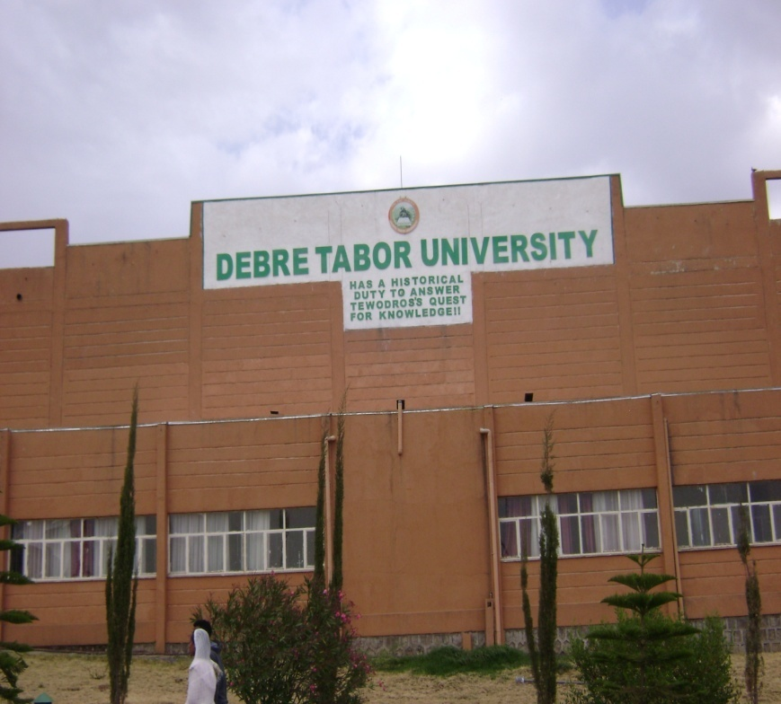

Figure1-Library, Vision and Mission of DTU

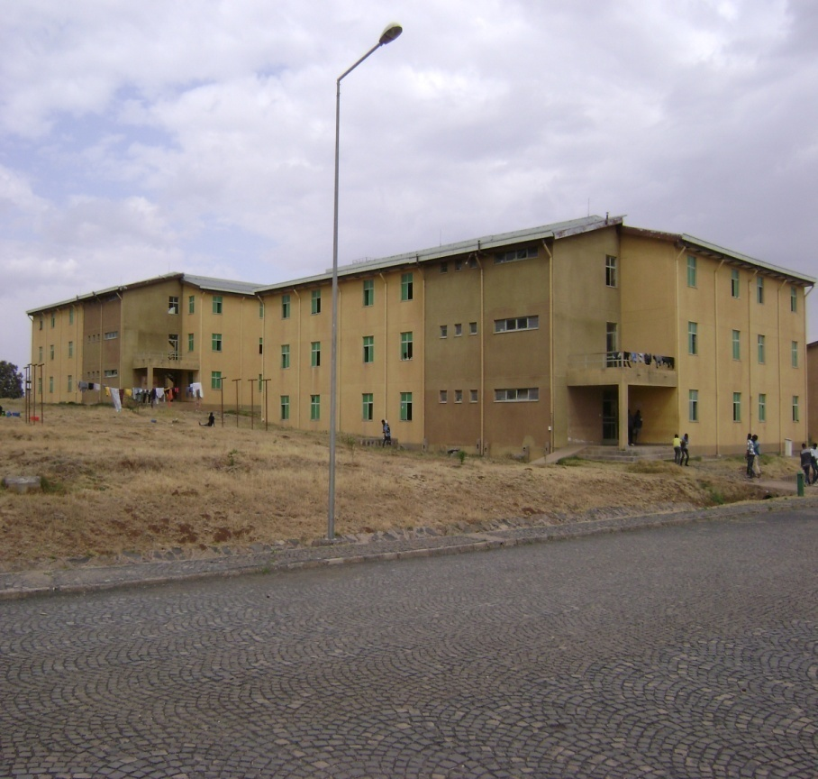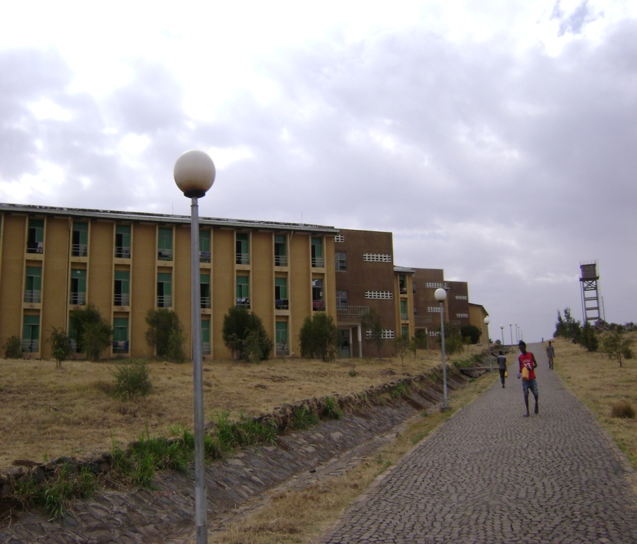

Figure 2-Dormitories (CYT+DHB Buildings) & Road Section (Infrastructure)

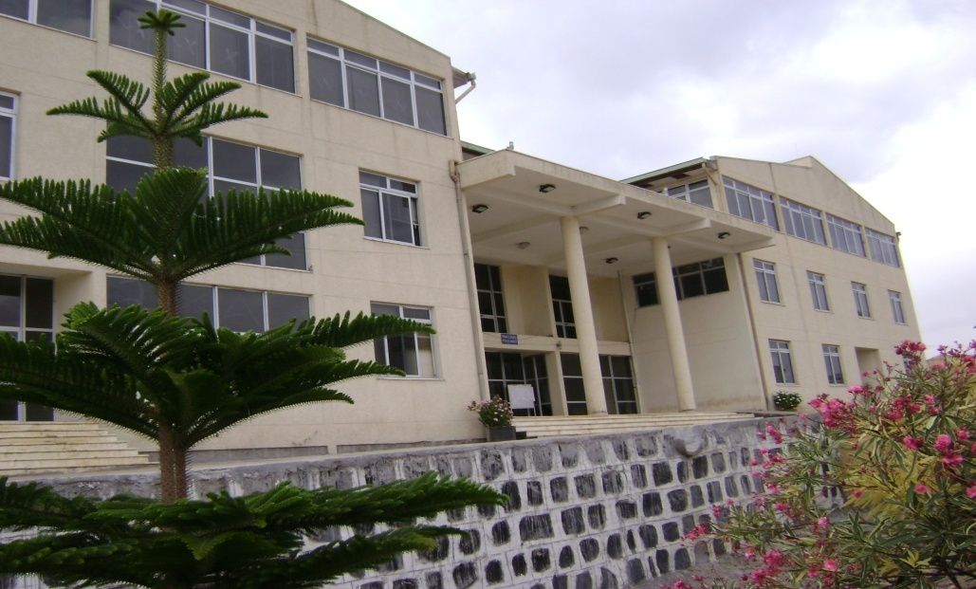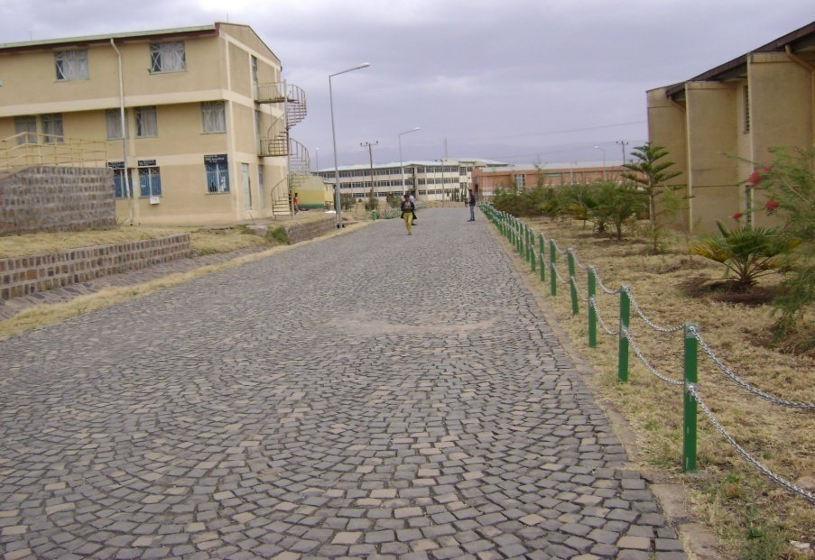

Figure 2- Main Administrative Buildings and Road Sections

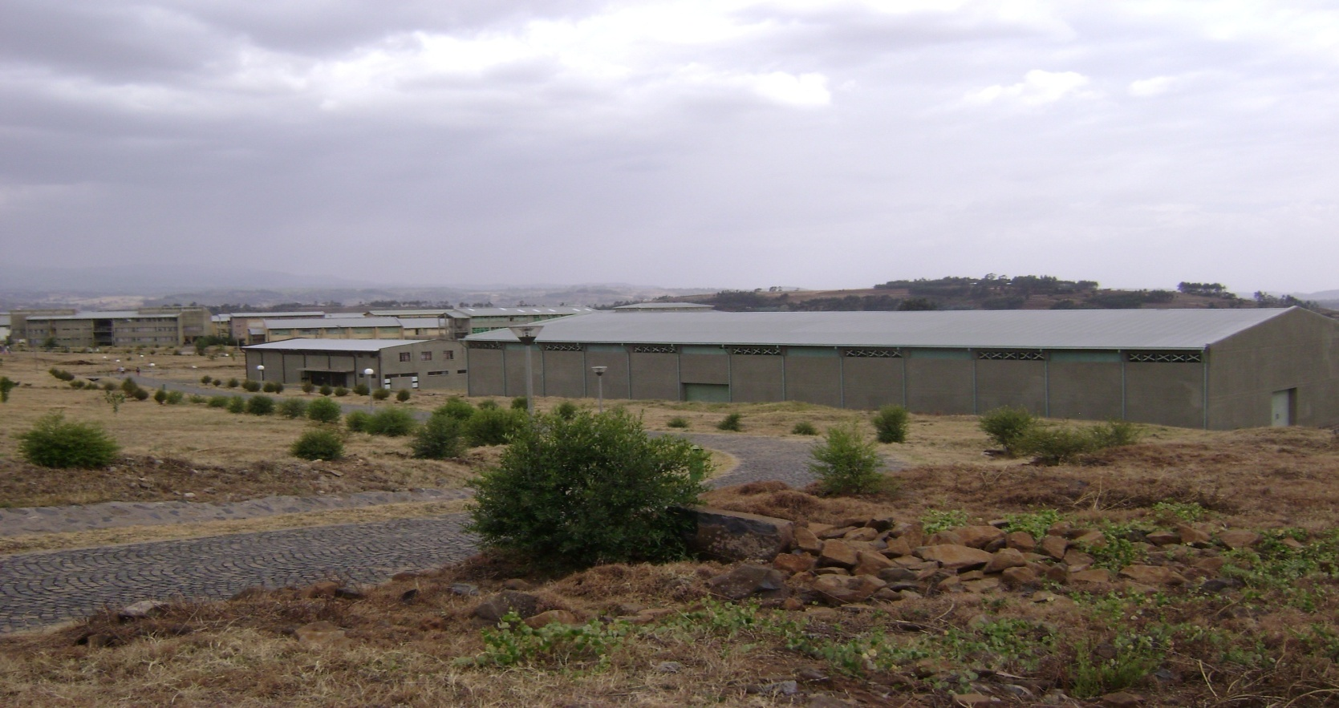
Figure 4-Laboratory Buildings

Annex 1. Contraction of CYT & DHB Buildings
S. No. | Main Designer of DUT | Consultant or Supplier of DUT | Services Provided or Works Executed | Amount of contract Price (ETB) | Contract Date (G.C. or E.C.) | Duration of Agreement for the execution/completion of works | Construction Type (Infrastructure or CYT+DHB | Construction Round & Phase | Remarks
I | MH Engineering Plc Consulting E/A |  | Detail Design of DTU Consultancy service for Construction Supervision | ETB =11 Million (for all Ten (10) New Universities) | May 15, 2009 G.C | Three Months | - | - | Note; Contract prices are Darken ones
II |  | Ultimate Plan Plc Consulting A/E  Tel.:0115522925/26  Fax:011-5522928 A.A | Planning, Design Adaptation, Supervision Works | ETB= ETB= 5,583,825.00 ( including 15% VAT) This contract price includes infrastructure, CYT & DHB contract prices | 25th September , 2009 G.C. | From 1st year to the 5th year | - | Up to the completion of the project (5year period) | As stated in WBD analysis as, not specified in Contract Agreement
III | Amdemichael Temesgen, Grade-III  General Contractor |  | - Road Works  - Sanitary Works  - Electrical Works | - Phase- I Infrastructure Works  LOT-A =38,708,640.06  LOT B =13,562,298.22  - Phase-II Infrastructure Works =35,451,345.49  - Total=87,722,283.76  - 15% =13,158,342.56  - G. Total=100,880,626.32 -CP | 10th June, 2011 G.C. | The Completion Date for the two Phases (Phase-I & Phase II) is after 730 Calendar days (or Two Years) | Infrastructure | Infrastructure Phase-I (LOT- A & LOT -B) & Infrastructure Phase-II
1 | Takele Tadele –Grade-V  General Contractor |  | - DO-CYT Block No.213  - DHB-T2 Block No. 104 Lot-B | ETB= 16,769,120.56 including 15% VAT | December 01, 2014 G.C | 270 days | CYT+DHB | Participated from Phase IV Round IV | In the completion time, it says 270 cal days for B.No.213 & 210 C. days for B.No.104, Total 270 C days.
2 | Assefa Alemu B.C. Grade- IV Building Contractor |  | - Block Do-T1 G+2 B-240  - Cupboard work (Variation)  - Terrazzo tread & riser (variation) | 6,946,195.96  704,933.83  26,496.0  Total=7,988,125.35 including 15% VAT (CP) | 06/06/2007 E.C | 150 days | CYT+DHB | Phase I from round 3-4
3 | Biruk Delelegn Grade-VI Building Contractor |  | - Dormitories  - Laundry | - 5,916,486.25  - 303,961.49  - Sub-Total=6,220,447.74  - 10 % Contingency=622,044.77  - Total=6,842,492.51  - 15% VAT=684,249.25  - G. Total=7,526,741.77-CP | May 07, 2010 G.C. | 180 days | CYT | Phase I from round 3/4th
4 | Takele Tadele B.C. Grade-V Building Contractor |  | Dormitories | - 5,916,486.25  - Sub-Total=5,916,486.25  - 10% Contingency.=591,648.63  - Total=6,508,134.88  - 15% VAT=650,813.49  - G. Total=7,158,948.36-CP | May 07, 2010 G.C. | 180 days | CYT | Phase I from round 3/4th
5 | Mulugeta Biazen Grade B.C |  | 1.Kitchen 1  2.Dinning hall T1 1  3.Laboratory L1 1  4.Classroom 1 | - 1.3,512,396.87  - 2,617,325.92  - 4847,105.98  - 3,235,308.96  - Sub-Total=13,212,137.73  - 10% contingency.=1,321,213..77  - Total=14,533,351.50  - 15% VAT=2,180,002.73  - G. Total=15,986,686.65-CP | May 07, 2010 G.C. | 270 days | CYT |  | There is a mistake in computation of Contract price ( Case 15% VAT)
6 | Agegn Demissie B.C. |  | 1.Semonar M1L 1  2.Lecture Hall D1 1  3.Library L1-T1 1 | - 1.3,776,497.81  - 2.1,352,302.51  - 3.6,285,228.02  - Sub-total=11,414,028.34  - 10%Conti.=1,141,402.83  - Total=12,555,431.17  - 15% VAT=1,255,543.12  - G.Total=13,810,974.29-CP | May 07, 2010 G.C. | 240 days | CYT
7 | Takele Tadele G.C. |  | General Store | 1. Total=1,723,213.87  2. 15% VAT=258,482.08  3.Grand sum=1,981695.95-CP | 18th June, 2011.G.C. | 120 days | CYT |  | For overall
8 | Kest G.C. Grade -V Building Contractor |  | - 1.Dormitary Type 1WTV(DO-T1/TV-227)  - 2.Washing Basin (LN-T2-312)  - Washing Basin (LN-T2-310) | - 5,007,497.87  - 347,854.46  - 348,098.94  4. Sub-total=5,703,451.27  5. 15% VAT=855,517.69  6. Total=6,558,968.96-CP  7. 10% Conti.=655,896.96  8. G.Total=7,214,865.86 | 3rd March ,2011 G.C. | 150 days | CYT | Phase I or II from round 3/4th , but significant delay of completion in 4th round has been mentioned in the document | Total Contract Amount is yellow shaded one
9 | Assefa Negash B.C. |  | - Dormitory (DO-T1/TV-129)  - Dormitory (DO-T1/TV-122) | - 4,994,420.65  - 4,996,953.20  - Sub-total=9,991,373.85  - 15% VAT=1,490,706.08  - Total=11,490,079.93-CP  - 10% contingency=1,149,007.99  - G. Total=12,639,087.92 | 3rd March,2011 G.C. | 150 days | CYT |  | Total Contract Amount is yellow shaded one
10 | Shegaw Almayehu B.C. |  | - Laboratory (LAB-T1-113) 1  - Seminar Building (SE-M1-111) | - 4,773,316.81  - 5,030,421.75  - Sub-Total=9,803,738.56  - 15% VAT=1,470,560.78  - Total= 11,274,299.34 -CP  - 10% Conti.=1,127,429.93  - G.Total=12,401,729.28 | 3rd March,2011 G.C. | 150 days | CYT
11 | Abay Demissie B.C. Grade- III |  | - Central library Small (L1-T1-117)  - Decentralized Admin. Building (DAB-T1-115)  - Lecture Hall Double (1-116) | - 7,998,722.75  - 2,659,385.14  - 1,597,676.04  - Sub-Total=12,255,783.93  - 15% VAT=1,838,367.59  - Total= 14,094,151.52 -CP  - 10% Conti.=1,409,415.15  - G. Total=15,503.566.67 | 3rd March,2011 G.C. | 180 days | DHB | Phase I or II from round 3/4th
12 | Alemnew Abrha B.C. Grade-III |  | - Laboratory (LAB-T1-132)  - Injera Bakery (IB-T1) | - 4,890,668.60  - 1,097,248.26  - Sub-Total=5,987,916.86  - 15% VAT=898,187.53  - Total=6,886,104.39 -CP  - 10% Conti.=668,610.44  - G.Total=7,574,745.75 | 3rd March,2011 G.C. | 150 days | CYT | Phase I or II from round 3/4, but significant delay of completion in 4th round has been mentioned in the document
13 | Biset Asmamaw B.C. Grade- II |  | - Dormitory Court yard (DO-CYT-T1-218)  - Dormitory Type 3 (DO-T3-217)  - Washing Basin (LN-T2-309) | - 8,033,049.86  - 3,056,090.29  - 310,578.25  - Sub-total=11,399,718.40  - 15% VAT=1,709,957.76  - Total=13,109,676.16-CP  - 10% onti.=1,310,967.62  - G.Total=14,420,643.78 | 3rd March,2011 G.C. | 150 days | CYT | Phase I or II from round 3/4th
14 | Assefa Alemu B.C. Grade-IV |  | - Dormitory (DO-T1/TV-221) | - 4,960,658.85  - 15% VAT=744,098.83  - Total= 5,704,757.68-CP  - 10% Conti.=570,475.77  - G. Total=6,275,233.45 | 3rd March,2011 G.C. | 150 days | CYT | Phase I or II from round 3/4th
15 | Haile H/Selassie B.C. |  | - Dormitory DO-T1/TV-220) | - 4,989,848.28  - 15% VAT=748,477.24  - Total=5,738,325.52-CP  - 10% Conti.=573,832.55  - G.Total=6,312,158.07 | 3rd March,2011 G.C. | 150 days
16 | Tilahune Dessie B.C. |  | - Decentralized Admin.Blg (DAB-T2-119) - 1  - Student Lounge (SL-T1-118) -1  - Work-shop (WS-  T1-144) - 1  - Bread Baker (BA-T2-14) -1 | - 2,706,135.96  - 952,204.44  - 1,721,650.95  - 711,143.09  - Sub-Total=6,091,134.44  - 155 VAT=913,670.13  - Total=7,004,804.61-CP  - 10% Conti.=700,480.46  - G.Total=7,705,285.07 | 3rd March,2011 G.C. | 120 days | DHB
17 | Hassen Abdella B.C. |  | - Dormitory Court Yard (DO-CYT-T1-225)  - Dormitory Type-3 (DO-T3-226) | - 8,046,610.34  - 3,063,765.69  - 15% Vat=1,666,613.69  - Total=12,777,371.60 -CP  - 10% Conti.=1,277,737.60  - G.Total=14,055,108.76 | 3rd March,2011 G.C. | 180 days | CYT
18 | Biruk Delelegn B.C. |  | - Clinical Building -1  - Washing Basin | - ETB=3,746,706.45  - ETB=241,382.48  - Subtotal=3,988,088.93  - 15% VAT=598,213.33  - Total=4,586,302.27-CP | 12th August, 2011 G.C. | 150 days | CYT | Phase-I or II  3/4th round
*CP-Contract Price
Totally about 14 contractors have been involved (according to the document issued by MoE).But
*Some contractors have been involved in the construction twice and more than twice:
E.g. 1 Takele Taddesse –Three-times (Three Different Contract agreements).
2. Birku Demissie- twice (has taken two different Contract Agreements).
3. Assefa Almu – twice (has taken two different Contract Agreements).

Annex 2. Standard Disclosure Template
DISCLOSURE OF PROCUREMENT & CONTRACT INFORMATION FOR INFRASTRUCTURE OF DTU
PHASE | ITEMS OF DISCLOSURE |  | DESIGN  (Contract 1) | CONTRACT ADMINISTRATION & CONSTRUCTION SUPREVISION -(Contract 2) | CONSTRUCTION WORKS  (Contract 3)
PROCUREMENT INFORMATION (30 ITEMS) | Date of Disclosure |  | April 25,2018 | April 25,2018 | April 25,2018
 | Contract Title |  | Detail design of DTU Infrastructures | Contract document preparation & construction supervision | Construction of CYT and DHB
 | Location |  | Addis Ababa | Addis Ababa | Amhara Regional Housing Development Project Offices
 | Procuring Entity |  | MoE | MoE | MoE on the Behalf of ANRHDP
 | Source for further Information |  | - MoE , 10 New Universities Project Construction Office  Mobile Phone: +251-911366748  - DTU Construction Project Office  Mobile Phone: +251-911042291 | - MoE , 10 New Universities Project Construction Office  Mobile Phone: +251-911366748  - DTU Construction Project Office  Mobile Phone: +251-911042291 | - MoE , 10 New Universities Project Construction Office  Mobile Phone: +251-911366748  - DTU Construction Project Office  Mobile Phone: +251-911042291
 | Date of Procurement Notice |  | NA | NA | NR
 | Floating Period of Procurement notice |  | NA | NA | NR
 | Media Used for Procurement Notice |  | NA | NA | NR
 | Method of Procurement |  | Direct Procurement | Open Bidding | Restricted Tendering
 | Type of Procurement |  | Consultancy Service | Consultancy Service | Works (CYT & DHB)
 | Procurement Procedure |  | Direct Procurement |  | Performance Directive
 | Evaluation Criteria |  | NA | Best Technical Fitness | Best Performance during the Housing Development Construction
 | Type of Contract & Project Delivery Method |  | Unit Price+ Design Bid Build | Lump sum+ Design Bid Build | Fixed Price
 | Type and Amount of Bid Security |  | - | - | -
 | Content of any Complaint lodged |  | - | - | -
 | Engineer’s Estimate |  | - | - | -
 | Date of bid opening |  | - | - | -
 | No. of Bidders Participated, rejected, declined to submit |  | - | - | -
 | Award Firm/Contracting Firm |  | MoE | MoE | Amhara Regional Housing Development Construction Project Office
 | Date of Contract Award |  | May 15, 2009 G.C | 25th September , 2009 G.C. | Most of Contractors on the days of May 07, 2010 G.C.& 10th June, 2011 G.C.
 | Award Price/Original contract Price |  | ETB =11 Million including VAT for Ten New Universities as a whole, not specified for Individuals (including DTU) | ETB= 5,494,125.00 Including 15% VAT | ETB=100,880,626.32 including VAT
 | Unit Contract Price(Price/Km, price/Sq. m) |  | - | - | -
 | Contract Security Type & Amount |  | NA | NA | NA
 | Date of Contract Signing |  | May 15, 2009 G.C | 25th September , 2009 G.C. | May 07, 2010 G.C & 10th June, 2011 G.C
 | Contract Scope |  | Design Adaptation of DTU | Contract Administration throughout project completion | Construction of Court Yard Type dormitories & Decentralized Head Office Buildings.
 | Description of Contract & Contract Components |  | Design Adaptation of DTU up slight modifications from previous 13 universities experience and Consultancy service for Construction Supervision | Consultancy Service for Contract Administration and Supervision Works of roads facility, Sanitary works, Electrical Installation works of DTU | Works-Construction of campus road facilities, Campus sanitary Works, Electrical Installation works
 | Contract Administration Entity |  | - | Ultimate Plan Consulting A/E Plc | -
 | Contract duration |  | 3 Months | Until the completion of Infrastructure construction works | Different Calendar Days for about 14 or more contractors, depending on project type. In most cases from the interval of 120 -270 calendar days.
 | Contract Start Date |  | After commencement | Three weeks after Commencement of Design Work | After commencement
 | Intended completion Date |  | Three months for design | - | -
DISCLOSURE OF CONTRACT INPLEMENTATION
CONTRACT IMPLEMENTATION (14 ITEMS) |  | Contract Status (ongoing % progress, terminated, completed | Completed
 |  | Completion date(Revised, Projected, Actual) | - | - | -
 |  | Change to contract Duration with Reason | There were no any changes in relation to contract duration | There were no any changes in relation to contract duration | There were no any changes in relation to contract duration
 |  | Amount of Liquidated Damage, if applied (Penalty for Delay) | - | - | -
 |  | Contract price (Revised, Projected, Actual) | There were no any contract price changes | There were no any contract price changes | There were no any contract price changes
 |  | Changes to Contract Price with Reason | There were no any changes in relation to contract duration | There were no any changes in relation to contract duration | There were no any changes in relation to contract duration
 |  | Scope at Completion | DTU have enrolled students starting 2005 E, C, No. of students increasing from time to time each year & about 7807 total students were enrolled in the year of 2007 E.C.
 |  | Change to contract Duration with Reason | NA | NA | NA
 |  | Total Payment Effected | ETB =11 Million including VAT | ETB= 5,494,125.00 Including VAT | Most Payment Certificates were not issued to know total payment effected
 |  | Warranty Type & Description | - | - | -
 |  | Details of Termination if Applied | - | - | -
 |  | Safety Measures (Accident & Death) | - | - | -
 |  | Quality of Work (Very Good, Good, Inferior, Impossible to comment) | DTU Project was completed before five years ago, for its major components like road works, sanitary installation works, electrical installation works, student dormitories, lounges, so quality issue was not inspected during the first project site visit.
 |  | Disputed Issues & Award Details | Construction of DTU has required about 126 hectares (1.26 km²) of land, which has been previously owned by 268 farmers. The disputed farmers were nearly paid ETB=10,535,105.70 for compensation and rehabilitation purposes for the displacement of farmers from their farm lands.
DISCLOSURE OF PROJECT INFORMATION
PRELIMINARY PROJECT INFORMATION (18 ITEMS) |  | Date of Disclosure | April 24,2018 | April 24,2018 | NA
 |  | Project Owner | Debre Tabor University
 |  | Project Name | Debre Tabor University Infrastructure
 |  | Sector, sub-sector | Education
 |  | Project location | Debre Tabor Town (East Gondar)
 |  | Project Purpose | To provide facility to the beneficiaries
 |  | Project Description | Development or Construction of Infrastructure works DTU includes Road works, Sanitary works, Electrical installation works, sport facilities and others, for the contemporary students and permanent dwellers of university
 |  | Original Project Scope | NA
 |  | Project Components | Design Adaptation: for infrastructure facilities  Consultancy Service: for construction supervision all infrastructure works  Contract Administration: for overall campus infrastructure works  Consultancy Services on : Contract Administration & Construction Supervision  Civil Works: Construction of roads, sanitary facilities electrical installations and others.
 |  | Environmental Impact | -
 |  | Land & settlement Impact | -
 |  | Estimated budget of the project with break –down of components | -
 |  | Funding Source(s) | Government Budget
 |  | Project Budget Approval Date | NA
 |  | Project Start Date ( Planned, Actual) | May 30, 2009 G.C | October 06, 2009 G.C. | -
 |  | Planned/Original Duration for Completing the Whole Project | - | - | -
 |  | Planned or Original Cost of Project | About 600,000,000.00 ( Not Verified from Other source)
DISCLOSURE OF PROJECT INFORMATION

PROJECT INFORMATION AT COMPLETION (8 ITEMS) |  | Cost of the Project at Completion | -
 |  | Change of project Cost with Reason | -
 |  | Project Completion Date (Revised, Projected, Actual) | -
 |  | Actual duration for Completing the Whole Project | -
 |  | Change of Project Duration with Reason | -
 |  | Project Scope at Completion | -
 |  | Change of Project Scope with reason | -
 |  | References to Documents for disclosure upon request (Reactive Disclosure) | - MoE , 10 New Universities Project Construction Office  Mobile Phone: +251-911366748  - DTU Construction Project Office  Mobile Phone: +251-911042291
*NA-Information Not Available (This is to mean that required information or documents were not issued by the concerned bodies (MoE, DTU, Consultants, & Contractors)
*NR-Not Required
*Information Completeness & Accuracy (At Procurement Information):45% (Reducing Number of not available/issued information).
* Information Completeness & Accuracy (At Contract Implementation): 65% >>
* Information Completeness & Accuracy ( At Preliminary Project Information:75% >>
* Information Completeness & Accuracy (At Project Information at Completion):85% >>
*- There were no any changes as information obtained from DTU

GLOSSARY: ALPHABETICAL LIST OF TERMS
Accountability (From CoST’s Point of View): CoST’s aim is to enhance the accountability of procuring bodies and construction companies for the cost and quality of public-sector construction projects. The core accountability concept is to ‘get what you pay for’. The ‘you’ in this context applies equally to national governments, affected stakeholders and to the wider public;
Bid: Means a stage in the procurement process extending from advertisement of or invitation to bid up to signing of contract.
Bidder: a natural or juridical person submitting a bid;
Bid Proposal: a document submitted by bidders to participate in a bid on the basis of the bid document prepared by a public body in respect of that procurement;
Budget: an amount of money allocated to a project or scheme;
Competitive Tendering: Awarding contracts by the process of seeking competing bids from more than one supplier; Construction Sector Transparency (CoST) Initiative: An international multi-stakeholder initiative designed to increase transparency and accountability in the construction sector;
Consultant: An organization or individual who has made a contract to provide services;
Consultancy Service: a service of an intellectual and advisory nature provided by consultants using their professional skills to study, design and organize specific projects, advice clients, conduct training and transfer knowledge;
Contract: A binding agreement made between two or more parties, which is intended to be legally enforceable;
Contract Documents: Documents incorporated in the enforceable agreement between the Procuring Entity and the contractor, including contract conditions, specification, pricing document, form of tender and the successful tenderers’ responses (including method statements), and other relevant documents expressed to be contract documents (such as correspondence, etc.);
Contractor: An organization or individual who has made a contract to undertake works, supply goods or provide services;
Contract period: An arrangement for the supply of works, goods or services established for a fixed period of time;
Effectiveness: Effectiveness means the extent to which the entity is able to procure goods, works and services of quality, in a timely and most economical manner.
Employer: In the context of the CoST initiative, the Procuring Entity awarding construction and consultancy contracts for the project; Feasibility study: An evaluation of a proposed project to determine the difficulty and likely success and benefits of implementing the project;
Environmentally Friendly or Environment-Friendly: guidelines and policies that claim reduced, minimal, or no harm upon ecosystems or the environment;
Fairness: Equal opportunity for all interested contractors, suppliers and consultants by providing a level playing field on which to compete and thereby, directly expands the public body’s options and opportunities for getting value for money.
Fixed-Price Contract: A fixed price strategy is an approach established a set price for each customer or client regardless of the actual time and materials used for a project. Such a scheme is often used by government contractors to put the risk on the side of the vendor, and control costs.
Standard Bidding Document: Means the document prepared by the Agency to serve as a point of reference in the preparation of bidding documents by Public Bodies.
Technical Specification: Means document describing the quality, type and standard with which the required goods, services, works or consultancy services should comply.
Tender Documents: Documents provided to prospective tenderers when they are invited to tender and that form the basis on which tenders are submitted, including instructions to tenderers, contract conditions, specification, pricing document, form of tender and tenderers responses;
Tender Evaluation: Detailed assessment and comparison of contractor, supplier or service provider offers, against lowest cost or most economically advantageous (cost and quality based) criteria;
Transparency: In the context of the CoST initiative transparency relates to the disclosure of material project information on construction projects;
Total Price: Means payment made by public bodies in respect of a particular procurement which includes taxes and all other incidental costs.
Value for Money: The optimum combination of whole-life cost and quality to meet the PEs and user's requirement;
Works: all work associated with the construction, reconstruction, up grading, demolition, repair or renovation of a building road, or structure, as well as services incidental to works, if the value of those services does not exceed that of the works themselves and includes build-own-operate, build- own-operate-transfer and build-operate- transfer contracts.

