CONSTRUCTION SECTOR TRANSPARENCY INITIATIVE
ETHIOPIA (COST – ETHIOPIA)

ASSURANCE LEVEL REPORT ON REACTIVE DISCLOSURE OF PROJECT AND CONTRACT INFORMATION:-
DEBRE TABOR UNIVERSITY: INFRASTRUCTURE PROJECT

By: Endale Bewketu (Assurance Professional)

November, 2018
ADDIS ABABA, ETHIOPIA

Contents
LIST OF TABLES 6
LIST OF FIGURES 6
ANNEXES 7
GLOSSARY 7
ABBREVIATIONS/ACRONYMS 8
EXECUTIVE SUMMARY 9
1. INTRODUCTION 12
1.1 Background 12
Table 1 List of Documents obtained from MoE & DTU. 14
Table 2 List of documents which were no Issued. 15
2. REACTIVE DISCLOSURE OF PROJECT INFORMATION 16
2.1 Project Overview 16
2.2 Scope of the Project 16
2.3 Socio-Economic Benefits (Purpose) of the Project 17
2.4 Undesired Impacts of the Project 17
2.5 Source of Funding and Project Cost 18
2.6 Project Duration 18
3. Reactive Disclosure of Procurement and Contract Information contract-1 19
3.1 Reactive Disclosure of Procurement Information 19
3.1.1 Overview of the Procurement Process 19
4. Reactive Disclosure of Procurement and Contract Information Contract-2 19
4.1 Reactive Disclosure of Procurement Information 19
4.1.1 Overview of the Procurement Process 19
Table 3. Technical and Financial Evaluation Process 21
4.1.2 Verification of the Reactively Disclosed Procurement Information 21
4.1.3 Analysis of the disclosed Procurement Information 22
4.2 Reactive Disclosure of Contract Information: 24
4.2.1 Overview of the Contract Information 24
4.2.2 Verification of Disclosed Contract Information 24
4.2.3 Analysis of Disclosed Contract Information 25
5. Reactive Disclosure of Procurement and Contract Information Contract-3 (Works) 26
5.1 Reactive Disclosure of Procurement Information 26
5.1.1 Overview of the Procurement Process 26
5.1.2 Verification of the Disclosed Procurement Information 27
5.1.3 Analysis of the Reactively Disclosed Information 28
5.2 Reactive Disclosure of Contract Information 29
5.2.1 Overview of the Contract Process 29
5.2.2 Verification of the Disclosed Contract Information: 30
5.2.3 Analysis of the Disclosed Contract Information 31
- Table 4 Payment Certificates for Infrastructure Works 31
- Table 5 Variation Orders for Infrastructure 33
- Table 6 Supplementary and/or Additional Works 33
6. Findings and Causes of Concerns 34
6.1 Findings 34
6.1.1 Consultancy Service for Planning, Design Adaptation, Contract Administration and Supervision Works. 34
6.1.2 Works (Infrastructure) 35
6.2 Causes of Concerns 36
6.2.1 Time Concerns 36
6.2.2 Cost Concerns 37
6.2.3 Quality Concerns 37
7. Conclusion and Recommendation 37
7.1 Conclusion 37
7.2 Issues Recommended for Further Review 39
Figure 1-Library, Vision and Mission of DTU 41
Figure 2-Dormitories (CYT+DHB Buildings) & Road Section (Infrastructure 42
Figure 3- Main Administrative Buildings and Road Sections 43
Figure 4-Laboratory Buildings 44
Annex 1. Standard Disclosure Format for Contract and Project Information Disclosure 45
GLOSSARY: ALPHABETICAL LIST OF TERMS 51

LIST OF TABLES
Table 1: List of Documents Obtained or Provided by MoE and DTU
Table 2: List of Missing Documents Required for Reactive Disclosure Information
Table 3: Technical and Financial Evaluation Process for Contact 2
Table 4: Payment Certificates for Infrastructure Works:
Table 5: Variation Orders for Infrastructure
Table 6: Supplementary and/or Additional Works

LIST OF FIGURES
Figure 1: Library, Vision and Mission of DTU
Figure 2: Student Dormitories (CYT+DHB Buildings) & Road Section (Infrastructure)
Figure 1: Main Administrative Buildings and Road Sections
Figure 4: Laboratory Buildings

ANNEXES
Annex 1: Standard Disclosure Format for Contract and Project Information Disclosure

GLOSSARY

ABBREVIATIONS/ACRONYMS
A/E  ANRS  ANRSHDPO  AP  CoST  CYT  DHB  DTU  E.C.  FDRE  ETB  IDS  MoE  MoWUD  NMSG-EC  PPAA  SDT/F  TR  UCBP  VAT  VOs | Architectures and Engineers  Amhara National Regional State  Amhara National Regional State Housing Development Project Office  Assurance Professional  Construction Sector Transparency Initiative  Court Yard Type  Department Head Building  Debra-Tabor University  Ethiopian Calendar  Federal Democratic Republic of Ethiopia  Ethiopian Birr  Infrastructure Data Standard  Ministry of Education  Ministry of Works and Urban Development  National Multi-Stakeholder Group Executive Committee  Procurement & Property Administration Agency  Standard Disclosure Template/Format  Terms of Reference  University Capacity Building Program  Value Added Tax  Variation Orders

EXECUTIVE SUMMARY
Construction Sector Transparency Initiative (CoST) aims to enhance the Transparency and Accountability of public-funded construction projects. The CoST’s expectation is to improve transparency & accountability which can lead to better management facilities & controlled use of public projects and also desirous to disclose accurate and complete disclosed information on selected sample projects during the capacity building training. To ensure that the information released is both accurate and available in a form that can easily be understood by stake holders, it would need to be verified and analyzed by the expert. In order to achieve this crucial task, NMSG-EC has appointed an Assurance Professional (AP) who is responsible to provide the professional expertise on data collection and verification process of reactively disclosed information. AP is also responsible to prepare an intelligible report on accuracy and completeness of the disclosed information by highlighting the main findings and causes of concerns. Thus, AP has taken responsibility to carry out the above mentioned task as stipulated in the contract agreement.
Description of the project and contracts included in the report are described as follows:
Date of Disclosure and Assurance: April 25, 2018 G.C.
Name of Assurance Professional: Endale Bewketu
Project Name: Debre Tabor University Infrastructure
Project Location: Project is found in Amhara National Regional State, on the Eastern Part of Historical Town ``Debre-Tabor`` at about 4 (four) kms away from the center of the town and it is located at 11° 51′ North of Latitude & 38° 01′ East of Longitude.
Project Owner: Debre Tabor University
For the execution of Infrastructure Project, the following contracts have been involved:
Contract 1: Consultancy Service for Design Adaptation (Design Guidance & Topology Adaptation) and Construction Supervision.
Consultant: MH Engineering PLC Consulting E/A,
Date of Contract Agreement: on May 15, 2009 G.C. between MoE & MH Engineering PLC Consulting E/A.
Contract 2: Consultancy Service for Planning, Design Adaptation and Construction Supervision (Contract Administration). Consultant: Ultimate Plan PLC Consulting A/E.
Date of Contract Agreement: on 25th September, 2009 G.C. between MoE & Ultimate Plan PLC Consulting A/E).
Contract 3: Works (Infrastructure)-Contractor: Amdemichael Temesgen Building Contractor-Grade-III (the contract agreement was made between FDRE- Move, Ten (10) New Universities Construction Project Office and Amdemichael Temesgen General Contractor on the day of 10th June, 2011 E.C.
The service contract for Planning, Design Adaptation (Design Guidance) and Construction Supervision (Contract 1) of Debre-Tabor University (which is among Ten New Universities) was issued to MH Consulting Engineers PLC based on the participation of previous 13 Universities Preliminary and Detail Design. For consultancy service of Contract Administration and Construction Supervision Works (Contract 2), only two (2) consultants were evaluated for their technical and financial proposals. AP has identified that additional works has been given to the same contractor at contract price of 14,250,582.21 million Birr including VAT), in addition to the main contract. From this AP has identified that provision of different works for only one and the same contractor may not guarantee the principle of PPAA rules and principles (mainly fairness and accountability during the public works contract processes).
Assurance Professional (AP) has faced challenges during the of data collection time. Especially obtaining necessary project information and required data (such as Feasibility Studies & Engineering Cost Estimate Documents, Bid Invitation & Tender Evaluation Documents for consultancy services, Scope or Contract Change Information). It is recalled that CoST-Ethiopia has written a letter on 23/11/2010 E.C. to Debre Tabor University in order to push University to cooperate and provide the required documents. Accordingly, DTU has responded on 09/12/2010 E.C. that the documents mentioned above were not available in the university.
Assurance Professional has identified the occurrence of different problems that has been influenced the construction activities. The associated problems that have been addressed in the available documents were poor coordination between the consultant (contract-2) and the contractor, design problems in road works, problems of consultant in timely provision of necessary information to the contractors, problems associated with consultant's construction supervisors not available at the construction sites at the right time at the right place, delay of release of finance on time and as necessitated to execute the construction activities properly, were main problems identified during the overall assessment of the available documents.

INTRODUCTION

Background
Cost Ethiopia is principally about increasing transparency through the release of project information in to the public domain. But it is recognized that the disclosure of this information may not be sufficient on its own to achieve greater accountability. This is because some of the information is likely to be complex and not easily intelligible to the general public. To ensure that the information released is both accurate and available in a form that can easily be understood by stakeholders, it would need to be verified and analyzed by the experts.
- The Overall Content of the Report:
The CoST-Ethiopia is aimed to know the transparency and accountability issues on publicly-financed Projects. In order to achieve this aim, the National Multi-Stakeholder Group-Executive Committee (NMSG-EC) has appointed an Assurance Professional (AP), who is responsible to carry out the Reactive Disclosure Information on publicly-financed construction projects. In order to perform this task, two sample projects were selected from DTU (the Infrastructure and CYT and DHB Projects). Under this part, DTU’s Infrastructure Project will be discussed.
AP is responsible to carry out the required task according to the terms of reference (ToR) stipulated in the contract agreement by collecting adequate and relevant documents and information from PE’s and where necessary from consultants and contractors in collaboration with the assigned PE’s staffs. To do this AP has traveled to the project site on Tuesday March 17, 2018 G.C. During the first project site trip, AP has made short and brief discussions with the contemporary President of DTU and assigned staffs about the overall objectives of CoST-Ethiopia and responsibilities of AP. President of DTU has shown an enthusiastic willingness to cooperate in providing or issuing all necessary documents and information required, and he has directed the letter written by CoST-Ethiopia, the letter asking DTU’s cooperation in providing all essential documents and information necessary for Public Disclosure Process to the assigned AP. Based on the available documents and information obtained, AP will verify and analyze the project information for its accuracy and completeness, and produce reports that are clearly intelligible to the non-specialists by highlighting main causes of concerns. Basically, conducting accurate and complete disclosed information on selected sample projects will rely on the availability of adequate and relevant documents from respective Procuring Entities and if possible from consultants and contractors.
- Objectives of Reactive Disclosure and Assurance Services:
- To verify the accuracy and completeness of Infrastructure Data standard (IDS) as outlined in the reactive disclosure information on the sample CoST projects,
- To analyze disclosed and verified data in order to make informed judgments about the cost, time and scope aspects of the CoST project, and
- To produce reports that are clearly intelligible to the non-specialist, outlining the findings in regard with the cost and quality of the infrastructure and highlighting any cause for concern that analyzed information revealed on CoST projects.
- Activities of Reactive Disclosure and Assurance Services:
- Collects project information from the PEs (in close collaboration with staffs from PEs) and, where necessary also collects information from consultants and contractors on selected projects in order to insure the publication of IDS as outlined in the Reactive Disclosure Standards of CoST-Ethiopia,
- Verifies the accuracy and completeness of the information collected,
- Makes site visit to have visual impression of the project and continues to make additional verifications as required,
- Produces reports that are clearly intelligible to the non-specialist, highlighting the main findings and causes of concern analyzed information reveals,
- Makes presentation to NMSG-EC, multi-stakeholder forums, get feedbacks and refine the reports accordingly.
- Challenges that AP has faced during the data collection process :
According to the work schedule, the first field trip to the project site was on Tuesday March 17, 2018. On the occasion, the short and brief discussions were held with DTU’s president and assigned staffs, about the overall objective of the AP’s assignment. However, AP has faced certain challenges during the data collection and verification process.
- Unable to have a contact and communication with DTU’s Construction Project Coordinator,
- Problems in obtaining adequate and relevant documents and information,
- Existence of limited cooperation in providing available documents and relevant information.

Table 1 List of Documents obtained from MoE & DTU.
Serial No. | Issued Documents | Procuring Entities |  | Remark
 |  | DTU | MoE
1 | Contract Agreement document for Infrastructure Works (for Contract-3)
2 | Payment Certificates (1-14) of Infrastructure Works
3 | Contract Agreement Documents for 14 contractors who were involved in the construction of CTY & DHB |  |  | Out of 14 contractors who were involved, only for 2 contractors of contract agreement documents were issued by DTU.
5 | Supplementary works (Road, sanitary, & electrical) contract document.
6 | Variation Orders No. 2 & No.3 for contractors of Infrastructure Works
7 | Contract Agreement document for Consultancy service of Contract Administration & Construction Supervision work |  |  | This document exists in the DTU office; however we were unable to provide because it was huge in size.
8 | Technical & Financial Evaluation Process Document (unofficial document) for the service of Contract Administration & Construction Supervision Works
9 | Selection information (unofficial Document) for consultancy Service of Design Adaptation & Construction supervision –Contract-1
10 | Progress report
11 | Audit Report Document

Table 2 List of documents which were no Issued.
Ser No. | Required Documents | DTU’s response about the Documents | MoE’s responses about Documents | Remarks
1 | Feasibility Study Report Document | This document may be available in MoE, but not available in our office. | Feasibility study was not carried out for the implementation of 10 new universities including DTU | AP has requested Ultimate Plan consulting A/E for the relevant documents in relation to DTU, unfortunately the firm could not cooperate
2 | Bid Invitation & Tender Evaluation Documents for consultancy services (contracts 1 & contract 2) | Bid Invitation & Tender Evaluation processes for consultancy services 1 & 2 were performed and evaluated by MoE, thus the documents can be obtained from MoE. | Official Bid Invitation & Tender Evaluation documents are available in our deadly storage room. There were no assigned documentation workers who are responsible and provide the required documents.
3 | ‘’Performance Directive Document’’ that was used the selection process of Infrastructure Contractor & CYT & DHB contractors. | The selection processes of contractors were based on their previous performances obtained during their participation in the housing development program, and the contract was given to the contractors on fixed price basis, but the so called Performance Directive document used to select contractors is not found in our office. | The Performance Directive Document was prepared by the Addis Ababa Housing Development Agency and distributed to the regional Housing Development Offices, thus the document may be available Offices of Agencies.
4 | Anticipated scope changes and contract prices changes | There were no any anticipated scope and contract price changes during CYT & DHB construction activities. | No information concerning project scope and contract price changes during the DTU project constructions.
5 | Documents related to Engineering Cost Estimates | Engineering Cost Estimate was prepared by MH consulting A/E, after it has got an acceptance from MoE, and the document was distributed to the contractors on fixed price basis, & the document can be obtained from MoE & MH Consulting Plc. | Engineering cost estimate was prepared by responsibility of Addis Ababa Urban Development Office, and may be available there.

REACTIVE DISCLOSURE OF PROJECT INFORMATION

Project Overview
The government of the Federal Democratic Republic of Ethiopia (FDRE), in its five years Development and Economic Growth Plan (Sustainable Development and Poverty Reduction Program, 2002-2007), has considered the Education Sector Program as a Cornerstone of the Capacity Building, Poverty Reduction and Sustainable Development Strategy. In addition to ensuring access to elementary education for all citizens, the education sector program aims to expand secondary and tertiary education throughout the country. Special Emphasis is placed on expansion of educational services in underprivileged regions and remote areas to achieve the important objectives of political and administrative decentralization, and balanced and equitable growth of the economy. It is primarily in line with this strategy that the construction of Ten (10) New Universities under UCBP has been envisaged and being implemented.
Debre-Tabor University is among the construction of Ten (10) New Universities to be implemented under five years Development and Economic Growth Plan. DTU was established in 2008 G.C., and its foundation had laid on the eastern part of the Historic Town Debre-Tabor at about 4 (four) Kms away from its center on 126 hectares of land. This area was previously owned by 268 farmers to whom nearly 10.5 million Birr was paid for compensation and rehabilitation. Among the 268 farmers, only 10 ceased farming and engaged in other occupations to earn their living. It was attempted to construct a total of 134 buildings out of which in the first round 35 buildings, in the second round 32 and in the third round 32 were successfully planted while the final 35 are on construction in 2007 fiscal year. Debre-Tabor University is found on the eastern part of historical Town ``Debre-Tabor`` at about 4 (four) kms away from the center of the town and it is located at 11° 51′ North of Latitude & 38° 01′ East of Longitude.

Scope of the Project
Debre Tabor University was among Ten (10) New Universities which was established in 2008. It was attempted to construct a total of 134 buildings out of which infrastructure project includes all works of Road, Sanitary and Electrical Installations all around the surrounding campus. The Overall Facility of Infrastructure works were executed only by one contractor and project is 100% completed and currently it is under service.
The university commenced its mission in 2011(2004 E.C.) and according to the statistics indicated the number of students enrolled in regular programs, in 2004 (2011/2012) Academic Year were about 311 Male & 317 Female Students, total of 628 students. However, this number has grown rapidly to 5015 Male & 2792 Female, total of 7807 enrolled students in Academic Year of 2007 E.C. (2014/2015 G.C.)

Socio-Economic Benefits (Purpose) of the Project
Debre Tabor University is dedicated to the supply of highly qualified and innovative human resource by providing societal needs-tailored quality education. Students will form the backbone of a qualified and adaptable human resource base that will drive Ethiopia’s Economic Development Forward. DTU comprises different facilities in it and among these facilities the infrastructure works were major facilities which provide road accesses, sanitary facilities, and electrical uses for the university communities of beneficiaries.

Undesired Impacts of the Project
Environmental Impact Issues:
Environmental Impact Assessment (EIA) is a key aspect of many large scale planning applications. It is a technique which is meant to help us understand the potential environmental impacts of major development proposals. In a nut shell, EIA is just an information gathering exercise carried out by the developer and other bodies which enables a Local Planning Authority to understand the environmental affects of a development before deciding whether or not it should go ahead. The really important thing about environmental assessments is the emphasis on using the best available sources of objective information and in carrying out a systematic and holistic process which should be bias free and allow the local authority and the whole community to properly understand the impact of the proposed development. Environmental assessment should lead to better standards of development and in some cases development not happening at all.
Environmental Impact Assessment (EIA) is a key aspect of many large scale planning applications. It is a technique which is meant to help us understand the potential environmental impacts of major development proposals. In a nut shell, EIA is just an information gathering exercise carried out by the developer and other bodies which enables a Local Planning Authority to understand the environmental affects of a development before deciding whether or not it should go ahead. The really important thing about environmental assessments is the emphasis on using the best available sources of objective information and in carrying out a systematic and holistic process which should be bias free and allow the local authority and the whole community to properly understand the impact of the proposed development. Environmental assessment should lead to better standards of development and in some cases development not happening at all.
Construction of DTU which includes infrastructure facilities has required about 126 hectares (1.26 km²) of land, which has been previously owned by 268 farmers, and nearly ETB=10,535,105.70 was paid for compensation and rehabilitation of those displaced Farmers. Among the 268 farmers, only 10 ceased farming and engaged in other occupations to earn their own living standards. AP considers as undesired impact here is that the statement in the document does not explain or address the final destinies of about 258 displaced farmers.

Source of Funding and Project Cost
The project is fully funded by The Government of Federal Democratic Republic of Ethiopia. According to the information obtained from MoE (Ato Tamene, 11 New Universities Construction Project Office Engineer, MoE. the budgeted estimated to DTU projects was ETB= 600,000,000.00 (Six Hundred Million).

Project Duration
The construction of DTU Infrastructure was divided in Two Phases based on their subsequent priorities. As stated in the contract agreement, the total construction duration for each phase was 365 Calendar days or 730 calendar days (Two Years) for the two phases. The contract agreement for the execution of infrastructure was made on the date of 10th June, 2011 G.C (02 June, 2003 E.C.).

Reactive Disclosure of Procurement and Contract Information contract-1

Reactive Disclosure of Procurement Information

Overview of the Procurement Process
Note: Assurance Professional (AP) will not further discuss concerning the Reactive Disclosure of Procurement and Contract Information concerning Consultancy Service -1 (Contract-1). The following information is only to highlight and introduce the NMSG-EC that who was the consultant involved in the Design Adaptation Providing Design Guide line or consultation, and, Topology Adaptation for Debre –Tabor University.
According to the information obtained from MoE, Design Adaptation up on slight modifications from the design experiences of previous thirteen (13) Universities, Provision of Design Guide Lines to the Newly Constructed Ten (10) Universities and Topology Adaptation were carried out by MH Consulting Architectures and Engineers Plc. However, there were no evidences disclosing about procurement and contract processes.
According to the information obtained from Eleven (11) University Construction Project Office, MH consultant was selected from his previous experience basis gained during the involvement of Design and Supervision of 13 Universities The selection process was based on consent of Higher Officials who were represented from MoE. In general, MH Consultant was selected for the Design Adaptation, Providing Design Guide Lines, and Typology Adaptation at a total contract price of ETB= Eleven (11) Million for Ten (10) New Construction of Universities including Debre-Tabor University.

Reactive Disclosure of Procurement and Contract Information Contract-2

Reactive Disclosure of Procurement Information

Overview of the Procurement Process
The Contract Agreement for the consultancy service of Planning, Design Adaptation, Contract Administration and Supervision Works was made between MoE and Ultimate Plan Plc Consulting Engineers and Architectures, on the day of September 25, 2009. The Procuring Entity has requested the supplier to carry out the above consultancy service and the Procuring Entity shall pay the supplier the contract Price of ETB=5,583,825.00 (Five Million Five Hundred Eighty Three Thousand Eight Hundred Twenty Five, including 15% VAT).
Note: The above contract price was total price for planning, Design Adaptation Supervision and Contract Administration of for both Projects (Infrastructure and CYT & DHB).
The Period within which the Service shall be commenced is Two (2) Weeks after the signing of the contract.
- Contract Duration for Design Work was Three (3) Months after the commencement of the design works,
- The Consultancy Service for Contract Administration Supervision Works had planned until the completion of the project.
As stated in the unauthorized document (document without official stamp) issued by MoE, bid invitation process has been carried out by the MoE. But the date of bid invitation, total number of registered bidders, and rejected bidders with the reason were not stated in the available document. In the Technical and Financial Evaluation procedures, only two (2) candidates were evaluated for their final nomination.
On the basis of technical and financial evaluation points, Ultimate Plan Consulting A/E Plc has been selected for Contract Administration and Construction Supervision Works of both DTU’s infrastructure. It was recalled that CoST-Ethiopia has written a letter to 10 new University Construction Project Office, MoE on the day of 09/08/2010 E.C. After accepting the official letter, project office has shown an enthusiastic corporation as much as possible. For this takes, 11 New Universities Construction Project Office Engineer Tamene Yigletu was the responsible one who facilitated providing available documents. He has cooperated providing relevant documents, except bid invitation & Tender Evaluation Documents for both consultancy services contract 1 & 2. After essential discussions, AP has tried to observe documentation store, the store was deadly locked store, i.e. it has been closed for years, no any responsible worker in providing required document, and documents were placed disorderly, thereby difficult to identify the required documents.
Generally the store was highly in a messed condition so that the situation has become very difficult to separate and found the required document as needed. There was no a responsible workers who can identify and provide the desired document. Because of above stated difficult situation, AP was unable to get an official Bid Invitation & Tender Evaluation Documents and has faced producing accurate and complete disclosed information about Bid advertisement and tender evaluation processes.
The figures tabulated in the Table 3 below describes Technical and Financial Evaluation process as was taken from unauthorized (unofficial) document obtained from the MoE. AP is responsible for this information and used this information only to verify that Tender Evaluation processes have been carried out by the MoE.

Table 3. Technical and Financial Evaluation Process
No | Bidders' Name | Final Accepted Contract Amount Exclusive of 15% VAT | Weighted technical score (80%) | Weighted financial score (20%) | Total Score (100%) | Rank
1 | Ultimate Plan A/E Consulting Plc | ETB=5,494,125.00 | 72.5 | 16 | 88.5 | 1
2 | National Consulting A/E Plc | ETB=5,777,866.00 | 70.8 | 14.6 | 85.4 | 2

Verification of the Reactively Disclosed Procurement Information

Completeness of the Disclosed Procurement Information
Verifying the completeness of Disclosed Procurement Information substantially relies on the issued or provided documents or information by the concerned procuring Entities. From the Standard Disclosure Format Requirement, the average completeness of reactive disclosure of procurement information was about 55%.

Accuracy of the Disclosed Procurement Information
Accuracy of the Disclosed Procurement Information mainly relies on the issuance of related documents by each contracting bodies. Very limited documents were issued from MoE. The Accuracy of the Disclosed Procurement Information can be taken from SDT as 50%.

Analysis of the disclosed Procurement Information

Compliance of the procurement Process with Rules of Advertisement
As observed from unofficial document, Ultimate Plan Consulting Architectures and Engineers Plc was select on the basis of Technical and Financial Evaluation process for the execution of Contract Administration and Construction Supervision Works of DTU projects. In order to verify whether procurement process (on time bid invitation, appropriate bidding dates, fair registration of competent bidders, reliable selection and rejection processes ) was in compliance with rules of advertisement or not, it shall have been cross-checked from authorized documents , however this was not happen.

Efficiency of the Procurement Process
Official documents revealing about timely bid advertisement, number of registered bidders, rejected bidders, number of selected bidders, date of bid proposal submission, bid opening, appropriateness of bid evaluation process (technical and financial evaluation) were not available, and as a result AP was unable to verify the efficiency of the procurement process.

Fairness of the procurement Rules on Participation
In order to verify fairness of the procurement rules on participation solely relies on the concrete evidences or relevant documents, as a result this was not possible due to missing documents.

Transparency of the Tender Evaluation Process
For the service of Planning, Design Adaptation, Construction Supervision (Contract Administration), three candidates were evaluated for their Technical and Financial Capacities, as discussed in section 5.1.1; the least bidder or supplier (ultimate Plan Consulting form Plc) was selected among other two candidates. However, this information was obtained from the unauthorized/unofficial document issued by MoE, but it was not cross-checked from the concrete evidences.

Objectivity of the Tender Evaluation and the Award Criteria
The evaluation of tenders is the stage in the procurement process during which a contracting authority identifies which one of the tenders meeting the set requirements is the best one on the basis of the pre-announced award criteria, either the lowest-priced or the most economically advantageous tender. The qualified tenderer whose tender has been determined to be either the lowest-priced or the most economically advantageous, as the case may be, is awarded the contract.
The award criteria are the criteria that constitute the basis on which a contracting authority chooses the best tender and awards a contract. These criteria must be established in advance by the contracting authority and must not be prejudicial to fair competition. In order to confirm the above objectivity of Tender Evaluation and Award Criteria in the implementation of DTU infrastructure works, unwillingness of providing related documents by the contracting bodies has made the information incomplete.

Competitiveness of the Award Criteria
Only two consultants were evaluated for the consultancy service of Contract Administration and Construction Supervision. The detail award process was not clearly stated in the available document. As there were no additional supporting documents and clear information, verification and analysis was not satisfactorily carried out by AP in order to compare and contrast the competitiveness of the award criteria between the competitive bidders.

Overview of Contract Milestones: Original Scope, Time and Cost
From the latest response or information obtained from DTU’s assigned members, there were no any changes concerning original project scope, time, & cost issues. Moreover, documents revealing the changes of original project scope, time, and cost were not available; AP is responsible for this disclosed information.

Reactive Disclosure of Contract Information:

Overview of the Contract Information
The contract agreement was made between MoE and Ultimate Plan Plc on the day of 25th September, 2009 G.C. The procuring Entity has requested the supplier to provide certain consultancy services as defined in the contract. The supplier having represented the Procuring Entity that it has required professional skills, personnel and technical resources, having agreed to provide the services on the terms and conditions set forth in the contract. According to the contract document, the supplier or consultant will provide the overall service on Planning, Design Adaptation and Contract Administration and Construction Supervision.
In the Contact Document, the following statements had been described and agreed between the two parties (MoE and the supplies or consultant):
- The Mutual Rights and Obligations of Procuring Entity and the Supplier shall be as set forth in the contract, in particular:
- The supplier shall carry out the services in accordance with the provisions of contract; and
- The Procuring Entity shall pay the supplier the contract price of ETB= 5,583,825.00 (Five Million Five Hundred Eighty Three Thousand Eight Hundred Twenty Five) including 15% VA) and other sum as may become payable under the provision of contract, at the time and in the manner prescribed by the Contract.
The Period within which the Service shall be commenced is Two (2) Weeks after the signing of the Contract. Contract Duration for Design Work was Three (3) Months after the commencement of the design works. Planning, Design Adaptation, Construction Supervision (Contract Administration) Consultancy Service has been continued until the project completion.

Verification of Disclosed Contract Information

Completeness of the Disclosed Contract Information
Verifying the completeness of Reactively Disclosed Procurement Information substantially relies on the issued or provided documents for cross-checking purposes. Full Contract Document for the service of Planning, Design Adaptation, and Construction Supervision, or Contract Administration and Construction supervision, in some document, was obtained only from MoE, Ten New Construction Project Office. Even though, the document issued by MoE, was complete and official document, for need of further cross-checking purpose of completeness of Reactively Disclosed Contract Information, the additional documents/evidences shall have been provided by DTU. Thus, the completeness of disclosed contract information will be one sided. Hence AP has put his own judgment that the completeness of reactive disclosure of contract information was 75% on the basis of SDF requirement.

Accuracy of the Disclosed Contract Information
The accuracy of disclosed contract information also depends on the availability of adequate and relevant documents and further attempt will continue to provide additional information. As required in SDT Accuracy of the Disclosed Procurement Information can be taken as 70%.

Analysis of Disclosed Contract Information

Issues Related to Contract Price

Documents revealing any deviation or anticipated contract price changes were not issued contemporarily from both of bodies, MoE, and DTU. As a result providing reliable information about changes on contract price compared to the original contract price. Thus, AP was unable to include justified and confirmed information on changes to the original contract price.

Issues Related to Contract Duration
As stated in the contract agreement document: the period the expiration of the contract for the design work is:
- Three (3) months after the commencement of design work or such other time as parties may agree;
- The Construction Supervision and Contract Administration Consultancy Service: up to the completion of the construction work.

Issues Related to Contract Scope
Documents explaining or revealing any contract scope or project program changes were not issued by MoE, DTU, Consultants, or Contractors. Basically the documents issued/provided by MoE DTU assigned staff was very limited and further verifications and justifications were influenced. Thus, producing necessary and reliable information concerning any changes of contract scope, compared to original contract scope was a crucial problem in this report.
The verification of the accuracy and completeness of Reactive Disclosure of Procurement and Contract Information was not possible because documents revealing about t procurement and contract process were not obtained. Accordingly AP was unable to provide concrete verification and analysis tasks on the overall procedures of Bid Advertisement & Procurement Processes. and was unable to cross-check whether Bid Advertisement & Procurement Processes were in compliance with rules and regulations of PPAA document or not.

Reactive Disclosure of Procurement and Contract Information Contract-3 (Works)

Reactive Disclosure of Procurement Information

Overview of the Procurement Process
For construction of DTU’s Infrastructure Works (Road, Sanitary and Electrical Installation) agreement was made between FDRE- MoE, Ten (10) New Universities Construction Project Office on behalf of Amhara National Regional State Housing Development Project Office and Amdemichael Temesgen General Contractor (Grade-III). The agreement was made on the day of 10th June, 2011 G.C.
The employer is desirous that the contractor executes the construction of the DTU Phase I and Phase II Infrastructure Works and the employer accepts the Bid by the contractor for the execution of such works and the remedying of any defects there in for the contract price of equivalent of ETB= 100,880,626.32 (One Hundred Million Eight Hundred Eighty Thousand Six Hundred Twenty Six 32/100 including 15% VAT).
SELCETION PROCESS: The constructions of Debre-Tabor University under the mandate of MoE (on behalf of Amhara Regional Housing Development Project Office) from 2002 to 2003 E.C. From 2004 to the time of completion, it was delivered to be controlled under Debre-Tabor University.
The selection process of the infrastructure contractors was based on the “Performance Directive’’ document. This document was prepared by Addis Ababa Housing Developments Project Office (AAHDPO) and the document was distributed to Regional Housing Development Project Offices. On the basis of Performance Directive, the selection process was performed by a committee comprising five (5) members who were represented from different Regional Organizations (such as Regional Housing Development Project Office, Regional Industry and Urban Development Bureau- Directorates and Amhara Regional District Construction Project Offices). For the selection process of infrastructure contractor, three (3) contractors were nominated as described below:
- Amdemichael Temesgen Building Contractor (Grade-III)……Selected
- Nigussie Worku Building Contractor (Grade –III)……………Reserved
- Eneyew Alemu Building Contractor (Grade-III)……………..Not selected
Generally the overview of disclosure of Procurement Process information was based on the Performance Directive, which was prepared by the Addis Ababa Housing Development Project Office on the fixed price basis.

Verification of the Disclosed Procurement Information

Completeness of the Disclosed Procurement Information
The ‘’Performance Directive’’ document was not available from both MoE, & DTU offices. AP has tried all his best to get this document; unfortunately the document was not available, thus it was not easy for AP to verify the accuracy and completeness of procurement information and to address that whether the document comply with the principles of PPAA or not. Therefore the completeness of the procurement information was taken as 75 % complete as it was overviewed from SDT.

Accuracy of the Disclosed Procurement Information
The accuracy of the procurement information to an acceptable standard can be considered from obtained documents from both entities and have been cross-checked and verified for its relative accuracy to be about 70% as taken from SDT count.

Analysis of the Reactively Disclosed Information

Compliance of Procurement Process with the Rules of Advertisement
The content of ‘’Performance Directive’’ document shall have been assessed in order to cross-check whether or not the document is in compliance with rules of PPAA. However, this document was not available in any of PEs.

Efficiency of the Procurement Process (Timeliness)
Bid advertisement, date of bid proposal submission, bid opening and bid evaluation processes were not found. Thus, efficiency of the procurement process was unable to be cross-checked.

Fairness of the Procurement Rules on Participation
Tender Evaluation Process was based on the ‘’Performance Directive’’, considering the best performances basis of contractors during their involvement in the construction of Regional Housing Development Program.

Transparency of the Tender Evaluation Process
In order to discuss about transparency of Tender Evaluation Process the ‘’Performance Directive’’ document shall have been obtained and cross-checked whether or not in compliance with rule of PPAA document. Because of the missing data, the verification of transparency of tender evaluation process was not addressed well.

Objectivity of the Tender Evaluation and award Criteria
The evaluation of tenders is the stage in the procurement process during which a contracting authority identifies which one of the tenders meeting the set requirements is the best one on the basis of the pre-announced award criteria, either the lowest-priced or the most economically advantageous tender. The qualified tenderer whose tender has been determined to be either the lowest-priced or the most economically advantageous, as the case may be, is awarded the contract. The award criteria are the criteria that constitute the basis on which a contracting authority chooses the best tender and awards a contract. These criteria must be established in advance by the contracting authority and must not be prejudicial to fair competition.

Competitiveness of the Award Price
For the construction of DTU Infrastructure works, three candidates were involved. The selection process was undertaken by the committee members on the basis of Performance Directive document prepared by AAHDPO. In order to cross-check whether the awarded price was competitive or not the overall content of Performance Directive document shall have been assessed carefully, unfortunately the document was not available.

Overview of Contract Milestones: Original scope, Time and Cost
There were no evidences revealing the original scope change issues. DTU assigned staff has also confirmed that there were no any anticipated original scope, time and cost changes.

Reactive Disclosure of Contract Information

Overview of the Contract Process
The employer is desirous that the contractor executes the construction of DTU Phase-I and Phase-II Infrastructure Works and the Employer has accepted the contractor’s Bid document, for such works and remedying of any defects. As stated in the contract agreement document, the commencement date of the project was after fifteen (15) Calendar days from the signing of the contract. Generally the construction of infrastructure project is divided in to Two Phases, Phase-I & Phase-II.
Activities Under Phase-I : (LOT-A: Internal Access Road, Site Electrical Works, and Site Sanitary Works (including ground water reservoir, elevated water tank, septic tank and oxidation pond). (LOT-B: Internal Access Road, Site Electrical Works, and Site Sanitary Works for the second phase.
Activities under Phase-II: - Internal Access Road, Site Electrical Works, Site Sanitary Works and Fence for the Third & Fourth phase buildings.
It was stated in the contract document, the intended Completion Date for Phase-I works shall be 365 calendar days (one year) after the commencement of the project. Similarly the intended Completion Date for Phase-II shall be 365 Calendar days after the completion of phase-I activities (i.e. after 365 days). The completion date of Phase-I and Phase-II shall be at the end of 730 Calendar Days after signing of contract as stated in detail in the contract document.

Verification of the Disclosed Contract Information:

Completeness of the disclosed Contract Information
AP has identified that information provided about contract information on DTU Infrastructure works was sufficient enough to address complete information. MoE and DTU’s assigned staffs have provided contract documents comprising similar contents and acceptable information. The issued documents were providing adequate information in a timely manner and kept its consistency across time. Thus, the completeness of the disclosed contract information could be taken as 85% complete.

Accuracy of the Disclosed Contract Information
In providing information to an acceptable standard form, the available documents from both parties shall indicate the consistency of the content to be transformed in to the reliable information. The obtained documents show that their contents are consistent and addressable a complete information. The documents issued by each of concerned entities have been cross-checked and verified for the accuracy of the disclosed contract information and SDF requirement shows about 80 %.

Analysis of the Disclosed Contract Information

Issues Related to Contract Price

Documents revealing any deviation or anticipated contract price changes were not available from bodies, MoE, and DTU. According to the latest information provided from DTU assigned staffs there were no changes concerning contract prices. Thus, AP was not able to provide any concrete information concerning contract price changes during construction of DTU’s infrastructure.

Issues Related to Contract Duration
According to the assessment of the contract document, the intended completion date was 730 Calendar days for the execution of phase-I and phase-II infrastructure works. There were no documents showing any contract deviation from its project completion time. Latest response from assigned members of DTU has described that no contract duration changes have been happened or occurred during the construction of infrastructure works

Issues Related to Contract Scope
The comprehensive information obtained from both parties was describing that issues related to contract scope changes were not occurred during the implementation of infrastructure works. Thus, AP’s verification and analysis task is highly relied on the concrete evidences; hence the overall information is limited on the information provided.

Table 4 Payment Certificates for Infrastructure Works
Ser No. | Payment Certificate Numbers (PC. No.) for Lot A | Net Payment due to Contactor (Amount Paid to the Contractor) including 15% VAT-ETB
1 | Main contract+15% VAT | 44,569,166.08
 | Final payment- PC No. 1 | 1,941,266.52
2 | PC. No 2 | 5,756,211.20
3 | PC. No 3 | 4,798,202.52
4 | PC. No 4 | 7,310,806.10
5 | PC. No 5 | 5,297,819.52
6 | PC. No 6 | 274,071.05
7 | PC. No 7 | 1,495,260.08
8 | PC. No 8 | 825,540.56
9 | PC. No 9 | 2,625,391.95
10 | PC. No 10 | 1,728,716.95
11 | PC. No 11 | 1,884,855.55
12 | PC. No 12 | 2,305,093.88
13 | PC. No 13 | 5,569,005.34
14 | PCNo.15 | 3,000,538.96
 | Total Payment for Lot A | 89,381,946.26
16 | Payment Certificate Numbers (PC. No.) for Lot B
15 | Main contract | 13,562,298.22
16 | Supplementary contract No.1 | 929,900.94
17 | Variation Order No.2 | 983735.76
18 | Variation Order no.3 | 1,587,680.25
 | Sub total | 17,063,615.67
19 | 15% VAT | 2,559,542.27
20 | Total | 19,623,157.44
21 | Final PC. | 1,757,249.47
22 | Grand total Lot B | 21,380,406.91
Total Payment Certificate (Lot A+ Lot B) or Actual project cost |  | 110,762,353.17
Initial (main) total contract price for Infrastructure was ETB=100,880, 626.32
Difference b/n actual project cot & initial cost =110,762,353.17-100,880,626.32= 9,881,762.86

Table 5 Variation Orders for Infrastructure
Phase I Lot B | Variation Orders | Amount | Date of Contract Agreement | Remark
 | Supplementary contract No. 1 | 929,900.94 | June 10/2011 | Contractor :Amdemichael Temesgen G.C. grade III
 | Variation Order No. 2 | 983,735.76
 | Variation Order No. 3 | 1,587,680.25
 | Total | 3,501,316.95
 | 15 % VAT | 525,197.50
 | Grand Total | 4,026,514.49

Table 6 Supplementary and/or Additional Works
Ser.No. | Description Items | Contract Amount | Date of Supplementary Contract Agreement | Client | Consultant | Contractor
Supplementary works were: Road, Sanitary & Electrical work (Similar to Main Contract Works) | Phase I- Lot A | 6,751,283.05 | 15th January, 2015 G.C. | MoE-DTU | Ultimate Plan Consulting Plc | Amdemichael Temesgen G.C
 | Phase I-Lot B | 983,735.76 |  | >> | >> | >>
 | Phase II  Additional Work) | 4,656,791.81 |  | >> |  | >>
 | Total | 12,391,810.62 |  | >> | >> | >>
 | 15% VAT | 1,858,771.59 |  | >> | >> | >>
 | Grand Total | 14,250,582.21 | - | >> | >> | >>

Findings and Causes of Concerns

Findings

Consultancy Service for Planning, Design Adaptation, Contract Administration and Supervision Works.
According to the documents issued/obtained from MoE, there were number of information addressing problems associated with the services of Ultimate Plan Plc. The problems stated in the available documents were as described below:
- In most cases, consultant’s supervisors were not available on the project site at the right time and at the right place, as a result there were problems of providing work directions to the contractor’s workers;
- There were problems in providing necessary and completed design works to the contractors to begin their construction activities as early as possible in accordance with the time scheduled;
- Problems in submitting copies of contractors’ contract agreement that has been made with MoE and consultant; as a result there were serious problems on day to day construction activities;
- There were Road Design Problems that leads to time delays and the extra cost increment;
- Delay in release of finance on time and as required.
It is remembered that CoST-Ethiopia had written a letter on 23/11/2010 E.C. to the DTU, for the additional documents and DTU has responded on the date of 09/12/2010 E.C. AP has careful assessed those documents and identified that DTU has given thanks letter for good achievement/ performance to Ultimate Plan A/E Plc despite the fact that all the above problems (a- e) were happened. According to AP’s opinion, provision of such confirmation letter shows that the client was reluctant to the problems that have been happened. For all of the findings stated above, AP will take responsibility to ascertain that reactive information provided were identified and taken from the documents obtained from MoE & DTU.

Works (Infrastructure)
- Contract Agreement for Supplementary Work: Supplementary work for infrastructure was carried out by the contractor Amdemichael Temesgen General Contractor. Date of main contract agreement for infrastructure works ( Roads, Sanitary & Electrical Installations) was on the day of 10th June, 2011 G.C. at the total contract price of equivalent to ETB= 100,880,626.32 including 15% VAT. In addition to this main contract, a Supplementary Contract Agreement was made on the day of 15th January, 2015 (after four years from the main contract date). However, the works to be executed under the supplementary work were with same name to the main contract (i.e., roads, sanitary, and electrical installation works), at total contract price of ETB=14,250,582.21 including 15% VAT. AP has perceived and identified the following issues, while issuing supplementary work contract for the same and one contractor.
AP’s Overviews on the Provision of Supplementary Contract:
- There were no clear justifications or reasons stated in the available documents, why those similar works (the same name) were not included during the main contract agreement time, if they were the same and similar one? Otherwise, a clear reason shall have been presented in the contract documents.
- To provide supplementary work for the same contractor, the governing conditions such as performance or percentage progress of the main activity should have been stated in the supplementary contract agreement document. The provision of supplementary work to the same contractor shall not be carried out unless otherwise above criteria fulfilled and were set in the contract document.
- Additional Completion Time for the supplementary work was not specified in the supplementary contract agreement document.

Causes of Concerns

Time Concerns
On order to highlight and produce precise time concerns, adequate and relevant documents shall have been obtained from DTU. During the overall assessment of the latest documents issued from DTU (documents such as provisional acceptance letters from the consultant) the construction time has been extended.
The following causes of concerns for time delays were stated in the documents available from MoE as follows:
- Coordination problems associated with consultant in providing activity schedules and work orders to the contractors;
- Associated Road Design problems were obstacles for early start of road construction activities;
- Delay of release of finance on time and as necessitated to execute the construction activities properly;
- Existence of inappropriate coordination among the contracting Parties (Client, consultant, and contractor).
As were stated in the documents provided, these causes of concerns were potential causes for occurrence of significant time delays.

Cost Concerns
AP has tried to examine that the time delays were an adversarial causes for the extra time requirements, and increased cost expense. There signs indicating the existence of cost increment during the construction activities have been addressed in the available documents.
The Debre Tabor Infrastructure project was completed before three years ago, and currently it is providing its full services. Unfortunately, during his first project site trip, AP was unable to inspect quality aspects of the existing structures because of prohibition of security condition. Thus, AP has not determined any quality concerns as there were no tangible evidences revealing quality concerns.

7. Conclusion and Recommendation

7.1 Conclusion
The objective of this project task is to address the Reactive Disclosure Information on selected projects for the verification of accuracy and completeness the information obtained. This is accomplished by Disclosing Infrastructure Data Standard at all Stages of Construction Project Cycle, from the initial identification of project to the final completion. The principal aim of CoST is about to increase transparency through the release of project information into the public domain. In order to ensure that the released information is both accurate and available in a form that can easily be understood by stakeholders, it would need to be verified and analyzed by Assurance Professional appointed by the Multi-stakeholder Group Executive Committee.
The Assurance Professional is responsible to verify and analyze Reactive Disclosure of Information on Procurement and Contract Processes on the selected projects and has to produce reports that are clearly intelligible to the non-specialist, by highlighting the major findings and causes of concerns. Producing convincing and sound reports mainly relies on the adequate and relevant documents obtained from respective contracting bodies such as client or owner, consultant and contractor.
- Documents revealing Bid Invitation and Tender Evaluation Processes: for Consultancy Service of Design Adaptation and Construction Supervision (Contract-1);
- Documents revealing Bid Invitation and Tender Evaluation Processes: for Consultancy Service of Planning Contract Administration and Construction Supervision Works (Contract-2);
- Amhara National Regional State ‘’Performance Directive’’ Document used for selection process of contractors for Infrastructure Works (Contract-3);
Each party has given its own answer for the non issuance of above mentioned documents:
MoE: Responses the documents of Bid Invitation and Tender Evaluation processes for Contract-1 & 2 are available in the dead file or document shelf, but there is no an organized staff who is responsible to find and provide these documents from such dead and disorganized document Shelf.
DTU: Responses that the above mentioned documents are not available in DTU’s office, but may be available in the offices of MoE.
Consequently AP was not able to produce complete and accurate Reactive Disclosure of Information about Bid Invitation and Tender Evaluation Processes.
The main findings of Causes of Concerns under this Assignment were:
- Generally there were critical problems in documentation handling and organization, especially as observed from DTU project offices;
- There were indications describing possible happenings of early construction delays (time delays ) that can be taken as major causes for cost increments;
- Provisions of supplementary work contracts for the similar one individual contractor, without setting major preconditions, if so, this situation leads a controversial and disputable actions among the parties, moreover if the actions were not appropriate and unreasonable, the chances of participation of other contracting bodies will be affected and violated,
- The unorganized and uncoordinated relations between consultants and contractors have created serious problems during the early project construction activities that can be considered as indicators of time delays and possible cost increments.

7.2 Issues Recommended for Further Review
- In most cases, the existing data handling and organization system is an obsolete system, thus it has to be modernized and has to adopt scientific data-base system;
- Obtaining adequate and relevant documents or information from Client /owner, consultant and contractors is a crucial problem, to enhance the commitment and transparency among the contracting parties, supplementary promotions shall be widely applied to the contracting parties;
- The applicability of the Standard Bidding Document (SBD) prepared by the Agency to serve as a point of reference in the preparation of bidding documents by public bodies shall be maintained and consistently used especially in publicly financed projects;
- When Public bodies use the procurement Methods such as Single Source/Direct or Restricted Procurement Methods, the conditions that have contained in the procurement Methods , shall be clearly stated and explained in the contract documents prepared by any public bodies;
- AP recommends that the Reactive Disclosure of Information on public projects shall be usually considered before the projects become fully completed. From AP’s perception point of view, appropriate construction control measures can be better achievable if they are applied before the projects are fully completed.

LIST OF FIGURES
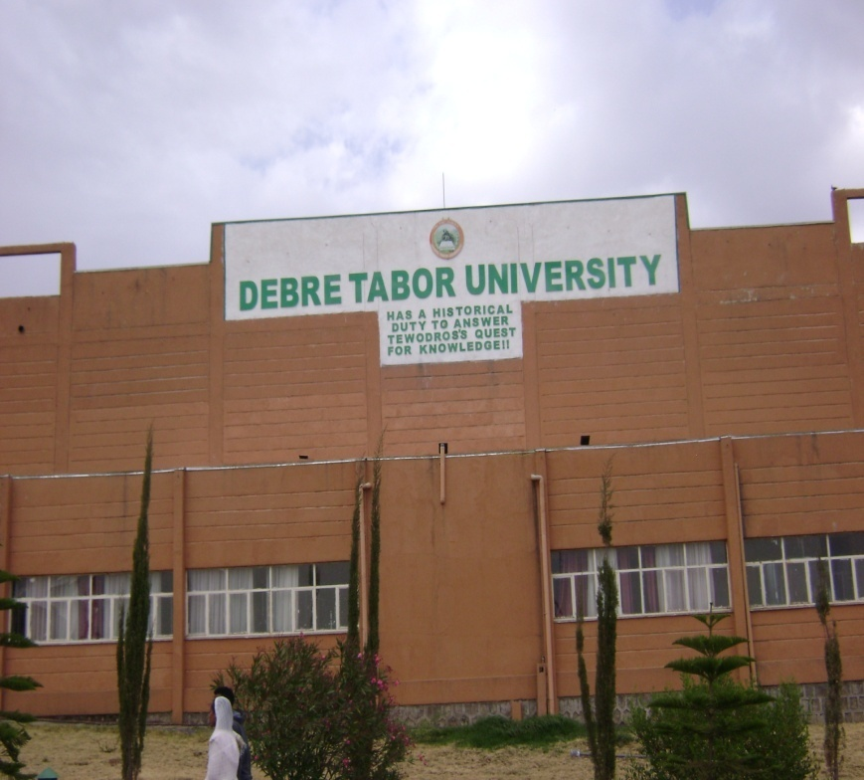

Figure 1-Library, Vision and Mission of DTU

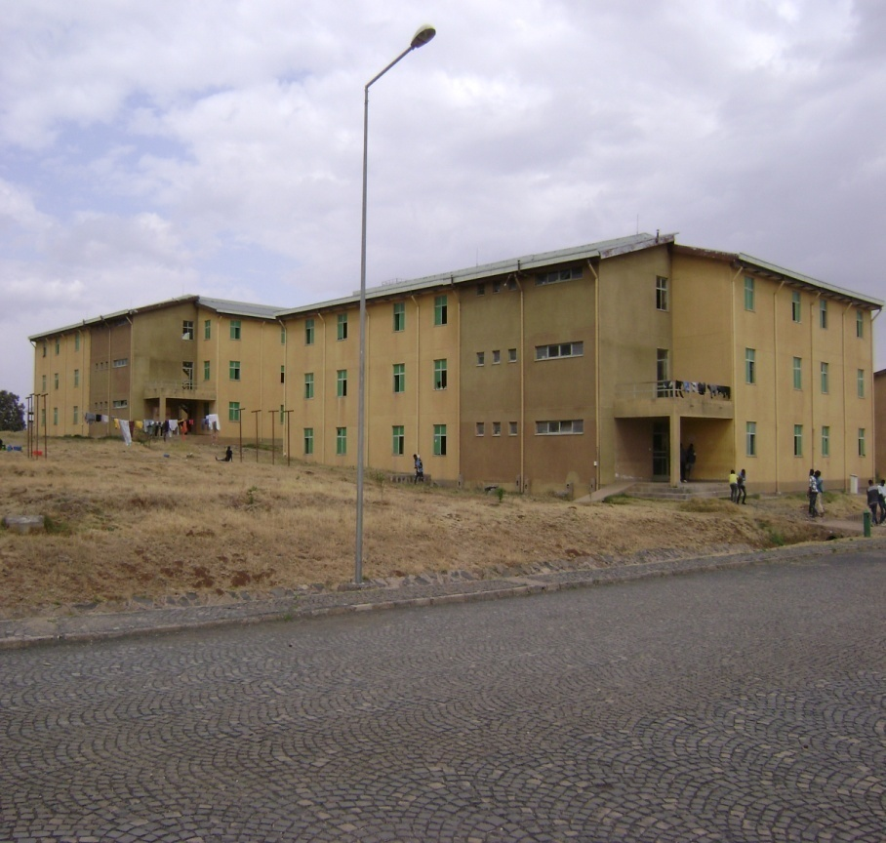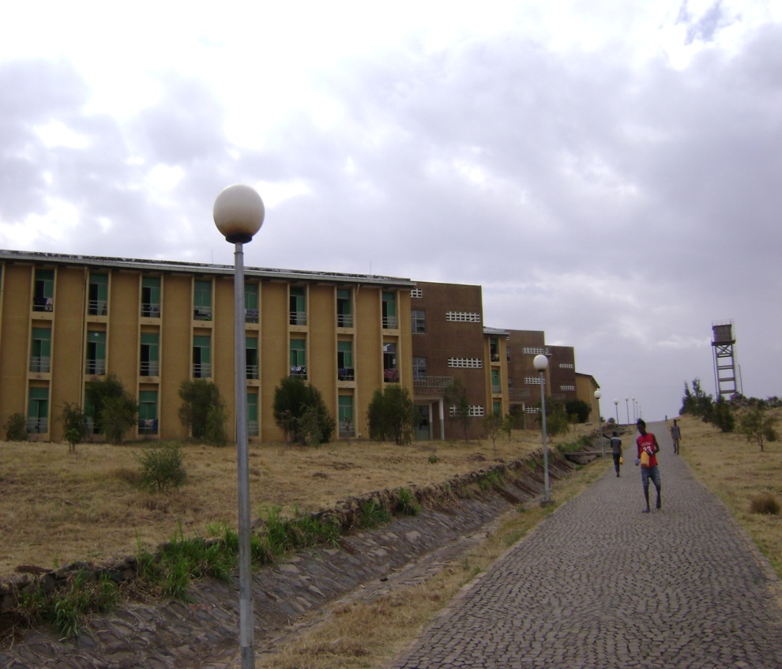

Figure 2-Dormitories (CYT+DHB Buildings) & Road Section (Infrastructure

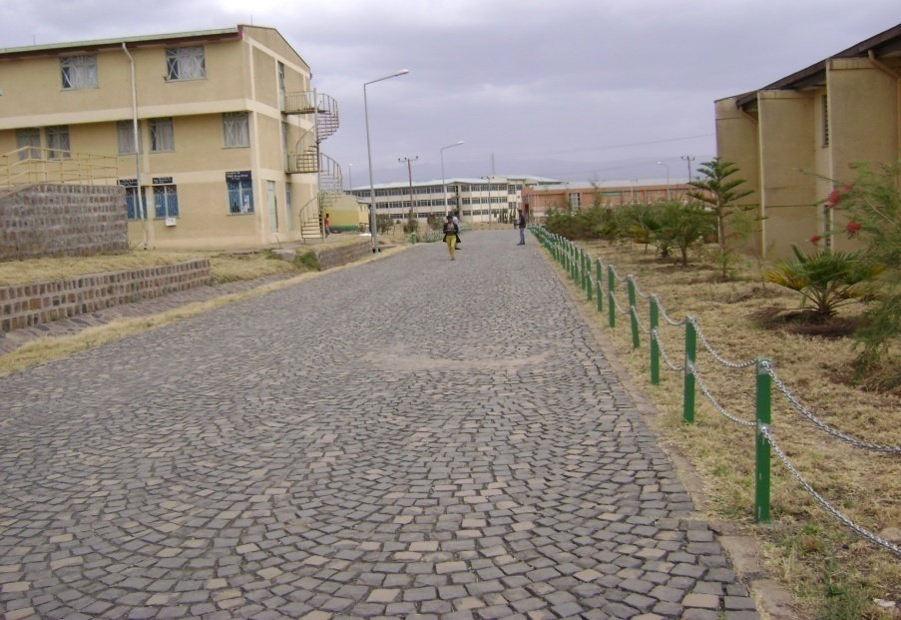

Figure 3- Main Administrative Buildings and Road Sections

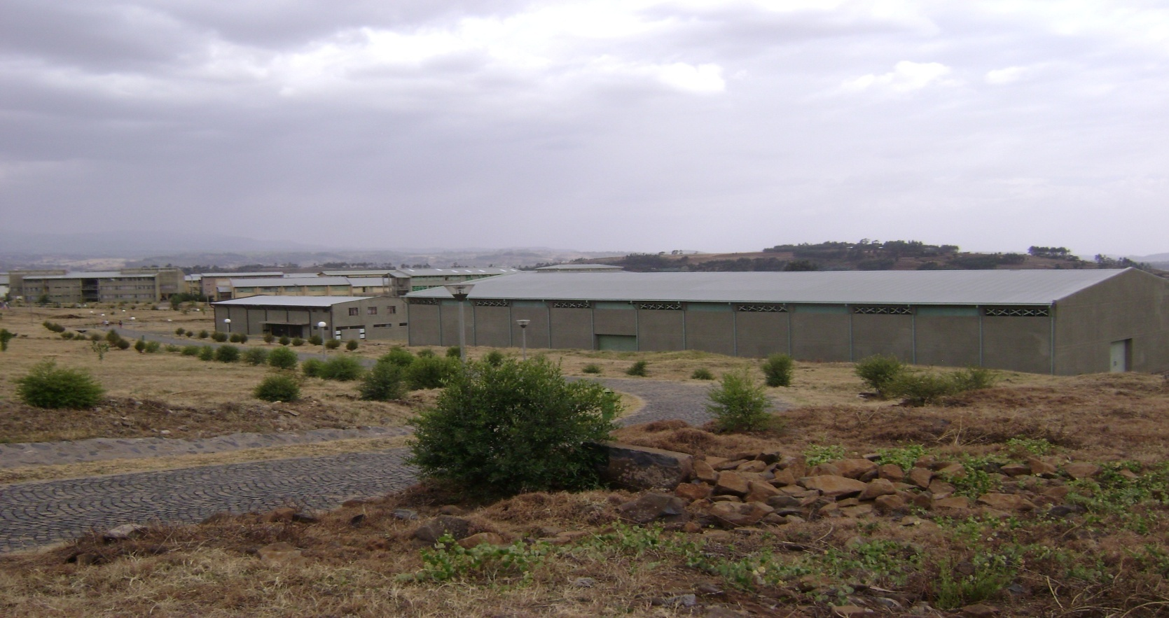

Figure 4-Laboratory Buildings

Annex 1. Standard Disclosure Format for Contract and Project Information Disclosure
DISCLOSURE OF PROCUREMENT & CONTRACT INFORMATION FOR INFRASTRUCTURE OF DTU
PHASE | ITEMS OF DISCLOSURE |  | DESIGN  (Contract 1) | CONTRACT ADMINISTRATION & CONSTRUCTION SUPREVISION -(Contract 2) | CONSTRUCTION WORKS  (Contract 3)
PROCUREMENT INFORMATION (30 ITEMS) | Date of Disclosure |  | April 25,2018 | April 25,2018 | April 25,2018
 | Contract Title |  | Detail design of DTU Infrastructures | Contract document preparation & construction supervision | Construction of DTU Infrastructures
 | Location |  | Addis Ababa | Addis Ababa | Bahir-Dar
 | Procuring Entity |  | MoE | MoE | MoE on the Behalf of ANRHDP
 | Source for further Information |  | - MoE , 10 New Universities Project Construction Office  Mobile Phone: +251-911366748  - DTU Construction Project Office  Mobile Phone: +251-911042291 | - MoE , 10 New Universities Project Construction Office  Mobile Phone: +251-911366748  - DTU Construction Project Office  Mobile Phone: +251-911042291 | - MoE , 10 New Universities Project Construction Office  Mobile Phone: +251-911366748  - DTU Construction Project Office  Mobile Phone: +251-911042291
 | Date of Procurement Notice |  | NA | NA | NA
 | Floating Period of Procurement notice |  | NA | NA | NA
 | Media Used for Procurement Notice |  | NA | NA | NA
 | Method of Procurement |  | Direct Procurement | Open Bidding | Restricted Tendering
 | Type of Procurement |  | Consultancy Service | Consultancy Service | Works
 | Procurement Procedure |  | Direct Procurement | Open Bidding | Performance Directive
 | Evaluation Criteria |  | NA | Best Technical Fitness | Performance Directive
 | Type of Contract & Project Delivery Method |  | Unit Price+ Design Bid Build | Lump sum+ Design Bid Build | Unit Price
 | Type and Amount of Bid Security |  | - | - | -
 | Content of any Complaint lodged |  | - | - | -
 | Engineer’s Estimate |  | - | - | -
 | Date of bid opening |  | - | - | -
 | No. of Bidders Participated, rejected, declined to submit |  | - | - | -
 | Award Firm/Contracting Firm |  | MoE | MoE | MoE, on behalf of ANRSHDP
 | Date of Contract Award |  | May 15, 2009 G.C | 25th September , 2009 G.C. | 10th June, 2011 G.C
 | Award Price/Original contract Price |  | ETB =11 Million including VAT for Ten New Universities as a whole, not specified for Individuals (including DTU) | ETB= 5,494,125.00 Including 15% VAT | ETB=100,880,626.32 including VAT
 | Unit Contract Price(Price/Km, price/Sq. m) |  | - | - | -
 | Contract Security Type & Amount |  | - | - | -
 | Date of Contract Signing |  | May 15, 2009 G.C | 25th September , 2009 G.C. | 10th June, 2011 G.C
 | Contract Scope |  | Design Adaptation of DTU | Contract Administration throughout project completion | Construction of Roads, Sanitary, Electrical Installation
 | Description of Contract & Contract Components |  | Design Adaptation of DTU up slight modifications from previous 13 universities experience and Consultancy service for Construction Supervision | Consultancy Service for Contract Administration and Supervision Works of roads facility, Sanitary works, Electrical Installation works of DTU | Works-Construction of campus road facilities, Campus sanitary Works, Electrical Installation works
 | Contract Administration Entity |  | - | Ultimate Plan Consulting A/E Plc | -
 | Contract duration |  | 3 Months | Until the completion of Infrastructure construction works | 730 Calendar days (Two Years)
 | Contract Start Date |  | Two weeks after commencement | Three weeks after Commencement of Design Work | Two weeks from the signing of contract.
 | Intended completion Date |  | Three months for design | End for construction | -
DISCLOSURE OF CONTRACT INPLEMENTATION
CONTRACT IMPLEMENTATION (14 ITEMS) |  | Contract Status (ongoing % progress, terminated, completed | Completed
 |  | Completion date(Revised, Projected, Actual) | - | - | -
 |  | Change to contract Duration with Reason | There were no any changes in relation to contract duration | There were no any changes in relation to contract duration | There were no any changes in relation to contract duration
 |  | Amount of Liquidated Damage, if applied (Penalty for Delay) | - | - | -
 |  | Contract price (Revised, Projected, Actual) | There were no any contract price changes | There were no any contract price changes | There were no any contract price changes
 |  | Changes to Contract Price with Reason | There were no any changes in relation to contract duration | There were no any changes in relation to contract duration | There were no any changes in relation to contract duration
 |  | Scope at Completion | DTU have enrolled students starting 2005 E, C, No. of students increasing from time to time each year & about 7807 total students were enrolled in the year of 2007 E.C.
 |  | Change to contract Duration with Reason | - | - | -
 |  | Total Payment Effected | ETB =11 Million including VAT | ETB= 5,494,125.00 Including VAT | Complete Payment Certificates were not issued to know total payment effected
 |  | Warranty Type & Description | - | - | -
 |  | Details of Termination if Applied | There was no any termination applied | There was no any termination applied | There was no any termination applied
 |  | Safety Measures (Accident & Death) | NA | NA | NA
 |  | Quality of Work (Very Good, Good, Inferior, Impossible to comment) | DTU Project was completed before five years ago, for its major components like road works, sanitary installation works, electrical installation works, student dormitories, lounges, so quality issue was not inspected during the first project site visit.
 |  | Disputed Issues & Award Details | Construction of DTU has required about 126 hectares (1.26 km²) of land, which has been previously owned by 268 farmers. The disputed farmers were nearly paid ETB=10,535,105.70 for compensation and rehabilitation purposes for the displacement of farmers from their farm lands.
DISCLOSURE OF PROJECT INFORMATION
PRELIMINARY PROJECT INFORMATION (18 ITEMS) |  | Date of Disclosure | April 24,2018 | April 24,2018 | April 2,2018
 |  | Project Owner | Debre Tabor University
 |  | Project Name | Debre Tabor University Infrastructure
 |  | Sector, sub-sector | Education
 |  | Project location | Debre Tabor Town (East Gondar)
 |  | Project Purpose | To provide facility to the beneficiaries
 |  | Project Description | Development or Construction of Infrastructure works DTU includes Road works, Sanitary works, Electrical installation works, sport facilities and others, for the contemporary students and permanent dwellers of university
 |  | Original Project Scope | There was no any change on the original project scope.
 |  | Project Components | Design Adaptation: for infrastructure facilities  Consultancy Service: for construction supervision all infrastructure works  Contract Administration: for overall campus infrastructure works  Consultancy Services on : Contract Administration & Construction Supervision  Civil Works: Construction of roads, sanitary facilities electrical installations and others.
 |  | Environmental Impact | -
 |  | Land & settlement Impact | -
 |  | Estimated budget of the project with break –down of components | -
 |  | Funding Source(s) | Government Budget
 |  | Project Budget Approval Date | -
 |  | Project Start Date ( Planned, Actual) | May 30, 2009 G.C | October 06, 2009 G.C. | June 30, 2011 G.C
 |  | Planned/Original Duration for Completing the Whole Project | There was no change | There was no change | There was no change
 |  | Planned or Original Cost of Project | About 600,000,000.00 ( Not Verified from Other source)
DISCLOSURE OF PROJECT INFORMATION

PROJECT INFORMATION AT COMPLETION (8 ITEMS) |  | Cost of the Project at Completion | There was no completion cost chages
 |  | Change of project Cost with Reason | There was no project cost change
 |  | Project Completion Date (Revised, Projected, Actual) | Project was completed according to its schedule, hence there was no any revised completion date
 |  | Actual duration for Completing the Whole Project | Project was completed according to its actual project duration.
 |  | Change of Project Duration with Reason | There were no any project duration changes during DTU’s CYT & DHB construction activities
 |  | Project Scope at Completion | There was no scope change at the project completion
 |  | Change of Project Scope with reason | There were no any project scope changes during DTU’s CYT & DHB construction activities
 |  | References to Documents for disclosure upon request (Reactive Disclosure) | MoE , 10 New Universities Project Construction Office  Mobile Phone: +251-911366748  - DTU Construction Project Office  Mobile Phone: +251-911042291
*NA-Information Not Available (This is to mean that required information or documents were not issued by the concerned bodies (MoE, DTU, Consultants, & Contractors)
*Information Completeness & Accuracy (At Procurement Information):45% (Reducing Number of not available/issued information).
* Information Completeness & Accuracy (At Contract Implementation):65% >>
* Information Completeness & Accuracy (At Preliminary Project Information):75% >>
* Information Completeness & Accuracy (At Project Information at Completion):85% >>
*The above information based on the latest DTU’s response given during the CoST-Ethiopia’s request for the provision of additional documents.
* -There were no any changes as information obtained from DTU

GLOSSARY: ALPHABETICAL LIST OF TERMS
Accountability (From CoST’s Point of View): CoST’s aim is to enhance the accountability of procuring bodies and construction companies for the cost and quality of public-sector construction projects. The core accountability concept is to ‘get what you pay for’. The ‘you’ in this context applies equally to national governments, affected stakeholders and to the wider public;
Bid: Means a stage in the procurement process extending from advertisement of or invitation to bid up to signing of contract.
Bidder: a natural or juridical person submitting a bid;
Bid Proposal: a document submitted by bidders to participate in a bid on the basis of the bid document prepared by a public body in respect of that procurement;
Budget: an amount of money allocated to a project or scheme;
Competitive Tendering: Awarding contracts by the process of seeking competing bids from more than one supplier; Construction Sector Transparency (CoST) Initiative: An international multi-stakeholder initiative designed to increase transparency and accountability in the construction sector;
Consultant: An organization or individual who has made a contract to provide services;
Consultancy Service: a service of an intellectual and advisory nature provided by consultants using their professional skills to study, design and organize specific projects, advice clients, conduct training and transfer knowledge;
Contract: A binding agreement made between two or more parties, which is intended to be legally enforceable;
Contract Documents: Documents incorporated in the enforceable agreement between the Procuring Entity and the contractor, including contract conditions, specification, pricing document, form of tender and the successful tenderers’ responses (including method statements), and other relevant documents expressed to be contract documents (such as correspondence, etc.);
Contractor: An organization or individual who has made a contract to undertake works, supply goods or provide services;
Contract period: An arrangement for the supply of works, goods or services established for a fixed period of time;
Effectiveness: Effectiveness means the extent to which the entity is able to procure goods, works and services of quality, in a timely and most economical manner.
Employer: In the context of the CoST initiative, the Procuring Entity awarding construction and consultancy contracts for the project; Feasibility study: An evaluation of a proposed project to determine the difficulty and likely success and benefits of implementing the project;
Environmentally Friendly or Environment-Friendly: guidelines and policies that claim reduced, minimal, or no harm upon ecosystems or the environment;
Fairness: Equal opportunity for all interested contractors, suppliers and consultants by providing a level playing field on which to compete and thereby, directly expands the public body’s options and opportunities for getting value for money.
Fixed-Price Contract: A fixed price strategy is an approach established a set price for each customer or client regardless of the actual time and materials used for a project. Such a scheme is often used by government contractors to put the risk on the side of the vendor, and control costs.
Standard Bidding Document: Means the document prepared by the Agency to serve as a point of reference in the preparation of bidding documents by Public Bodies.
Technical Specification: Means document describing the quality, type and standard with which the required goods, services, works or consultancy services should comply.
Tender Documents: Documents provided to prospective tenderers when they are invited to tender and that form the basis on which tenders are submitted, including instructions to tenderers, contract conditions, specification, pricing document, form of tender and tenderers responses;
Tender Evaluation: Detailed assessment and comparison of contractor, supplier or service provider offers, against lowest cost or most economically advantageous (cost and quality based) criteria;
Transparency: In the context of the CoST initiative transparency relates to the disclosure of material project information on construction projects;
Total Price: Means payment made by public bodies in respect of a particular procurement which includes taxes and all other incidental costs.
Value for Money: The optimum combination of whole-life cost and quality to meet the PEs and user's requirement;
Works: all work associated with the construction, reconstruction, up grading, demolition, repair or renovation of a building road, or structure, as well as services incidental to works, if the value of those services does not exceed that of the works themselves and includes build-own-operate, build- own-operate-transfer and build-operate- transfer contracts.

